
DEVELOPMENT, TECHNICAL EVALUATION, AND DEPLOYMENT OF A UGANDA CLINICAL GUIDELINES-GROUNDED SYMPTOM-BASED ILLNESS PREDICTION SYSTEM

A PROJECT REPORT

Submitted by
MIKE AYIKO
2401201555

A PROJECT REPORT SUBMITTED TO THE FACULTY OF TECHNOSCIENCE, DEPARTMENT OF COMPUTER AND INFORMATION SCIENCE IN PARTIAL FULFILLMENT OF THE REQUIREMENTS LEADING TO THE AWARD OF MASTER OF SCIENCE IN ARTIFICIAL INTELLIGENCE OF MUNI UNIVERSITY

July, 2026

Declaration
I, Ayiko Mike, hereby declare that this project report titled “Development, Technical Evaluation, and Deployment of a Uganda Clinical Guidelines-Grounded Symptom-Based Illness Prediction System” is my original work and has not been previously submitted, either in whole or part, for any academic award to any institution of learning.
Where other works, datasets, software libraries, frameworks, or deployment technologies have been consulted, they have been duly acknowledged and referenced in accordance with the prescribed academic guidelines.

Student’s Name: Mike Ayiko

Signature: Date:

Approval
This project report titled “Development, Technical Evaluation, and Deployment of a Uganda Clinical Guidelines-Grounded Symptom-Based Illness Prediction System” has been developed under our supervision and recommended for submission to the Department of Computer and Information Science with approval of:

Signature: Date:
Dr. Taban Habibu
Main supervisor

Signature: Date:
Mrs. Sarah Nawoya
Co-supervisor

Contents

Declaration i
Approval ii
Contents iii
List of Tables vii
List of Figures viii
List of Abbreviations and Acronyms ix
Abstract x
Chapter 1 1
Introduction 1
1.1 Background to the Study 1
1.2 Statement of the Problem 2
1.3 Purpose of the Study 3
1.4 Study Objectives 3
1.4.1 Main Objective 3
1.4.2 Specific Objectives 4
1.5 Research Questions 4
1.6 Scope of the Study 4
1.7 Conceptual Framework 5
1.8 Study Limitations 6
1.9 Significance of the Study 7
1.10 Organization of the Report 8
Chapter 2 9
Literature Review 9
2.1 Introduction 9
2.3 Uganda Clinical Guidelines and Local Clinical Relevance 10
2.4 Symptom Representation and Clinical Boundaries 11
2.5 Comparative Machine Learning Models 12
2.6 Data Preparation and Reproducible Modelling 13
2.7 Model Evaluation 14
2.8 Mobile and API-Based Deployment 14
2.9 Research Gap 14
Chapter 3 16
Materials and Methods 16
3.1 Introduction 16
3.2 Research Design 16
3.3 Data Sources and Clinical Foundation 17
3.4 Disease Selection Procedure 17
3.5 Symptom Identification and Clinical Mapping 19
3.6 Binary Encoding and Case Generation 19
3.7 Internal Validation and Consistency Checks 20
3.8 Data Preparation and Exploratory Analysis 20
3.8.1 Data Wrangling Procedure 20
3.8.2 Exploratory Data Analysis Procedure 21
3.8.3 Feature and Label Preparation 21
3.8.4 Data Splitting 21
3.9 Model Development and Evaluation 22
3.9.1 MLP Model Development 22
3.9.2 Traditional Machine Learning Models 22
3.9.3 Model Evaluation Procedure 23
3.10 System Implementation and Deployment 23
3.10.1 Overall System Architecture 23
3.10.2 API Implementation 23
3.10.3 API Endpoints and Response Generation 24
3.10.4 Frontend PWA Development 24
3.10.5 Deployment Procedure 26
3.11 Software and Tools 27
3.12 Research Code and Reproducibility 27
3.13 Methodological Limitations of the Extracted Dataset 28
3.14 Ethical Considerations 28
Chapter 4 30
Results and Discussion 30
4.1 Introduction 30
4.2 Dataset Construction Results 30
4.3 Dataset Preparation Results 31
4.4 Exploratory Data Analysis Results 32
4.5 Comparative Model Evaluation Results 36
4.6 MLP Training and Error Analysis 37
4.7 XGBoost Error Analysis and Feature Importance 38
4.8 Application Deployment Results 41
4.9 Integrated Discussion 42
Chapter 5 44
Conclusion and Recommendations 44
5.1 Introduction 44
5.2 Conclusion 44
5.3 Recommendations 45
5.4 Contribution of the Study 46
Chapter 6 48
Future Work 48
6.1 Introduction 48
6.2 Phase One: UCG Extraction Governance 48
6.3 Phase Two: Real-World Clinical Validation 48
6.4 Phase Three: Robust Model Evaluation and Safe Inference 49
6.5 Phase Four: User and System Evaluation 50
6.6 Translational Research Direction 50
Appendix A a
Algorithms and Source Code Access a
A.1 Algorithm 1: UCG-Based Disease and Symptom Extraction a
A.2 Algorithm 2: Binary Case Construction a
A.3 Algorithm 3: Data Preparation and Partitioning b
A.4 Algorithm 4: MLP Training b
A.5 Algorithm 5: Comparative Model Evaluation and Selection c
A.6 Algorithm 6: API Prediction and Response Generation c
Source Code Access d
Appendix B e
Example of a Binary-Encoded Training Record e
Appendix f
Research Timeline f
Appendix D h
Research Budget h

List of Tables
Table 3. 1: Illustrative UCG-based extraction for hypertensive presentations 19
Table 4. 1: Summary of dataset preparation results 32
Table 4. 2: Comparative model performance on the test set 36
Table B. 1: Vertical representation of one binary record extracted from the UCG e
Table C. 1: Research Timeline f
Table D. 1: Research Budget h

List of Figures
Figure 1. 1: Conceptual framework for the UCG-based illness prediction system 6
Figure 3. 1: Machine learning development and deployment pipeline 18
Figure 3. 2: Backend API architecture and inference flow 25
Figure 3. 3: Frontend architecture of the Quasar PWA 26
Figure 3. 4: Overall System and Production deployment Architecture 27
Figure 4. 1: Number of samples per disease in the full dataset 33
Figure 4. 2: Symptom frequency distribution in the full dataset 34
Figure 4. 3: Correlation among the top 20 symptoms 35
Figure 4. 4: Disease composition by symptom-frequency groups 36
Figure 4. 5: MLP training history 38
Figure 4. 6: Confusion matrix for the MLP model 39
Figure 4. 7: Confusion matrix for the XGBoost model 40
Figure 4. 8: XGBoost feature importance 41
Figure 4. 9: PWA prediction interface 42

List of Abbreviations and Acronyms
Abbreviation |  | Meaning
AI | - | Artificial Intelligence
API | - | Application Programming Interface
AUC-ROC | - | Area Under the Receiver Operating Characteristic Curve
ANN | - | Artificial Neural Network
F1-Score | - | Harmonic Mean of Precision and Recall
HTML | - | HyperText Markup Language
HTTP | - | Hypertext Transfer Protocol
HTTPS | - | Hypertext Transfer Protocol Secure
JSON | - | JavaScript Object Notation
ML | - | Machine Learning
MLP | - | Multilayer Perceptron
PWA | - | Progressive Web Application
REST | - | Representational State Transfer
ROC | - | Receiver Operating Characteristic
SQL | - | Structured Query Language
TLS | - | Transport Layer Security
UCG | - | Uganda Clinical Guidelines
UI | - | User Interface
uWSGI | - | Web Server Gateway Interface
UX | - | User Experience
VPS | - | Virtual Private Server

Abstract
Symptom-based machine learning can support preliminary illness classification, but the relevance and reproducibility of such systems depend on the provenance of their clinical features and the consistency of their deployment workflow. This study developed, technically evaluated, and deployed a symptom-based illness prediction system grounded in the Uganda Clinical Guidelines 2023. Diseases were selected according to clinical significance, regional relevance, clarity of guideline description, and representation across major condition groups. Primary symptoms, secondary symptoms, associated features, and relevant risk indicators were extracted and encoded as binary variables. Full, partial, variant, and atypical presentations were then generated subject to source and logical consistency checks.
The constructed training dataset contained 4,920 records across 41 equally represented illness classes. Removal of an empty column left 132 raw symptom variables, after which an engineered symptom-count variable produced 133 model features. Duplicate analysis identified 4,616 repeated records, leaving 304 unique training patterns. The development data were divided into 4,182 training and 738 validation records, while a separate 42-record test set was reserved for final evaluation. A multilayer perceptron, Logistic Regression, Random Forest, and XGBoost were compared using accuracy, macro precision, macro recall, macro F1-score, and macro AUC-ROC.
Each model correctly classified 41 of the 42 test records, achieving 97.62% accuracy, 98.78% macro precision, 98.78% macro recall, and 98.37% macro F1-score. The MLP recorded 99.36% macro AUC-ROC, while the conventional models recorded 100%. The equivalent aggregate performance indicated that increased model complexity provided no measurable advantage on the available test set. The selected MLP and XGBoost models were serialized, exposed through a Flask API, integrated with a Quasar Progressive Web Application, and deployed on a DigitalOcean VPS using uWSGI and Nginx.
The study contributes a reproducible workflow linking a locally identifiable clinical source, comparative machine learning evaluation, preserved inference artefacts, and operational web deployment. However, the repeated constructed patterns and small test set mean that the results demonstrate technical feasibility rather than clinical diagnostic effectiveness. Independent clinician review and validation using representative Ugandan patient data are required before healthcare use.
The supporting implementation is available at https://github.com/ayikomike/Symptom-Based-Illness-Prediction.
Keywords: Uganda Clinical Guidelines, symptom-based illness prediction, machine learning, multilayer perceptron, XGBoost, Progressive Web Application.

Chapter 1

Introduction

1.1 Background to the Study
Machine learning is increasingly applied to structured health data to identify patterns that support classification and preliminary decision support [1], [2]. Sharma et al. identify symptom-driven disease risk assessment as an important application in which computational methods analyse reported clinical features to support early assessment and individualized health guidance [3]. In symptom-based illness prediction, observed or selected symptoms are represented as input features and mapped to one of several illness classes. This formulation allows the same dataset to be evaluated using linear, ensemble, boosting, and neural-network models.
Previous studies have used both structured symptom vectors and free-text symptom descriptions for disease classification [4], [5]. Ragu and Perumal’s review of human disease prediction models further demonstrates the broad use of machine learning and data-analytics methods across disease-prediction tasks [6]. This literature shows that model performance depends on data representation, preprocessing, model selection, and evaluation design. Comparative evaluation is therefore necessary because a more complex model does not necessarily perform better than conventional machine learning methods on structured tabular data.
The Uganda Clinical Guidelines 2023 were the primary source used to extract and document the disease–symptom relationships in the dataset [7]. This local clinical foundation was relevant because model development for healthcare applications should account for the context represented in its source data [8]. Nevertheless, converting the UCG booklet into binary variables removed clinical detail, and the resulting dataset was not a collection of prospectively observed patient encounters.
This research implemented an end-to-end symptom-based illness prediction workflow. The UCG-derived dataset was constructed through documented disease selection, symptom profiling, binary encoding, case generation, and internal consistency checking. Disease profiles distinguished primary symptoms, secondary symptoms, associated features, and relevant risk indicators, while generated rows represented full, partial, variant, and atypical presentations compatible with the source descriptions. The subsequent workflow comprised data wrangling, exploratory analysis, feature and label preparation, comparative model training, test-set evaluation, model serialization, Flask API development, Quasar Progressive Web Application (PWA) integration, and deployment on a virtual private server. Four models were evaluated: a multilayer perceptron (MLP), Logistic Regression, Random Forest, and XGBoost.
The deployed system accepted symptom selections through the PWA, converted them into the saved feature order, and submitted them to Flask API endpoints. The API returned predictions from the deployed MLP and XGBoost models. Nginx was used for web serving and reverse proxying, while uWSGI served the Flask application. The research code, notebooks, model workflow, and API implementation are available in the project repository: https://github.com/ayikomike/Symptom-Based-Illness-Prediction.

1.2 Statement of the Problem
Symptom-based machine learning can support preliminary illness classification, but the usefulness of a prediction system depends on the clinical relevance, transparency, and reproducibility of the data from which it learns. Existing disease-prediction studies demonstrate the technical potential of structured symptoms, free-text descriptions, conventional classifiers, and neural networks [4], [7]. However, symptom-disease mappings are often obtained from generalized or insufficiently documented sources, making it difficult to establish how individual features were selected and whether the represented conditions reflect the intended setting. This is particularly important in Uganda, where locally authoritative clinical guidance and representative data are necessary to reduce the risk of applying models whose underlying assumptions are disconnected from national clinical practice [7], [8].
A second problem concerns the separation between model experimentation and operational implementation. Studies may report high classification accuracy without adequately documenting data cleaning, feature ordering, label encoding, model comparison, artefact preservation, inference preprocessing, or deployment. Machine learning-enabled mobile health applications are increasingly used for prediction, monitoring, and early detection, but their practical value depends on implementation decisions that connect analytical models to accessible and reliable applications [2]. Without a reproducible path from dataset construction to user-facing inference, it is difficult to verify reported results, reproduce predictions, or determine whether a trained model can function consistently outside its development notebook.
The UCG-derived dataset used in this study introduced additional methodological concerns that could not be addressed by accuracy alone. It contained many repeated symptom-disease patterns, only 304 unique training records after duplicate removal, and a separate test set of 42 records across 41 illness classes. Its binary representation omitted symptom severity, duration, chronology, demographics, comorbidities, examination findings, vital signs, laboratory results, and epidemiological context. If these characteristics were not explicitly examined, very high evaluation scores could be interpreted incorrectly as evidence of real-world diagnostic performance rather than performance on a finite, guideline-constructed classification task.
The research therefore addressed the absence of a documented, locally grounded, and deployable technical framework for symptom-based illness prediction using disease-symptom relationships extracted from the Uganda Clinical Guidelines 2023. Specifically, it investigated how the UCG-derived dataset could be prepared and analysed, how neural and conventional machine learning models could be compared under a consistent evaluation procedure, and how selected models and preprocessing artefacts could be operationalized through a Flask API and mobile-friendly PWA. The problem was addressed as one of technical prediction and system deployment; clinical effectiveness, patient outcomes, treatment recommendation, and replacement of professional diagnosis remained outside the study’s claims.

1.3 Purpose of the Study
The purpose of the study was to determine whether structured symptom-disease relationships extracted from the Uganda Clinical Guidelines 2023 could support technically reliable multi-class illness prediction and be operationalized through a reproducible, mobile-friendly application. The study therefore combined dataset construction, comparative machine learning evaluation, API implementation, frontend integration, and server deployment within one applied research workflow.

1.4 Study Objectives

1.4.1 Main Objective
The principal objective of this study was to develop, technically evaluate, and deploy a machine learning system capable of predicting illness classes from structured symptom inputs derived from the Uganda Clinical Guidelines 2023 booklet.

1.4.2 Specific Objectives
The study pursued five specific objectives. First, it extracted, encoded, cleaned, and documented a symptom-disease dataset from the Uganda Clinical Guidelines 2023 booklet. Second, it examined disease-class distributions, symptom frequencies, duplicate patterns, and associations among symptoms through exploratory data analysis. Third, it trained and compared MLP, Logistic Regression, Random Forest, and XGBoost models using consistent feature definitions, data partitions, and evaluation metrics. Fourth, it preserved the trained models and preprocessing artefacts and implemented Flask API endpoints for reproducible MLP and XGBoost inference. Finally, it integrated the API with a Quasar PWA and deployed the frontend and backend services on a virtual private server using Nginx and uWSGI.

1.5 Research Questions
The investigation was guided by five research questions corresponding directly to the specific objectives. The first examined how symptom–disease information extracted from the Uganda Clinical Guidelines 2023 could be encoded, cleaned, and transformed into a consistent feature space for multi-class classification. The second considered which class-distribution, symptom-frequency, duplicate-pattern, and symptom-association characteristics were present in the constructed dataset. The third compared the performance of the MLP, Logistic Regression, Random Forest, and XGBoost models on the reserved test set. The fourth examined how the trained models and preprocessing artefacts could be preserved and exposed through a Flask API for reproducible inference. The final question addressed how the prediction API could be integrated with and consumed by a deployed mobile-friendly PWA. Collectively, these questions connected the clinical source, analytical procedure, and operational implementation of the system.

1.6 Scope of the Study
The scope of the study was defined across data, modelling, implementation, and clinical dimensions. In relation to data, the documented UCG extraction produced Training.csv, while Testing.csv provided a separate evaluation file under the same structured symptom– disease schema. The prediction task was limited to the symptom features and 41 illness classes represented in these files. The modelling scope comprised data cleaning, exploratory analysis, label encoding, feature-order preservation, training, and comparative evaluation of the MLP, Logistic Regression, Random Forest, and XGBoost models using the performance measures reported in Chapter 4. Extensive hyperparameter exploration and external clinical validation were not undertaken.
The implementation scope covered model serialization, Flask API development, Quasar PWA integration, and deployment on a virtual private server. The API exposed separate MLP and XGBoost prediction routes as well as a combined endpoint, while uWSGI and Nginx supported the production architecture. The study established that the trained models could be accessed through the deployed application but did not include a formal usability study, load test, security audit, or offline-device evaluation. Clinically, the system was restricted to generating preliminary illness-class predictions from selected symptoms. It did not perform physical examination, laboratory interpretation, emergency triage, prescription generation, treatment recommendation, or clinical diagnosis; consequently, its outputs should be understood as technical decision-support results rather than clinical conclusions.

1.7 Conceptual Framework
The conceptual framework in Figure 1.1 links the clinical source, dataset-construction process, machine learning workflow, deployment components, and intended system outputs. The source-and-preparation component begins with the Uganda Clinical Guidelines 2023 and proceeds through disease selection, clinical symptom extraction, binary encoding, and data preprocessing. The modelling component covers feature preparation and comparative development of Logistic Regression, Random Forest, XGBoost, and MLP models. Model evaluation and serialization connect this analytical workflow to the Flask API, Quasar PWA, and production server infrastructure. The outcome component is an accessible symptom-based illness prediction system that returns an illness class and confidence score as preliminary decision support.
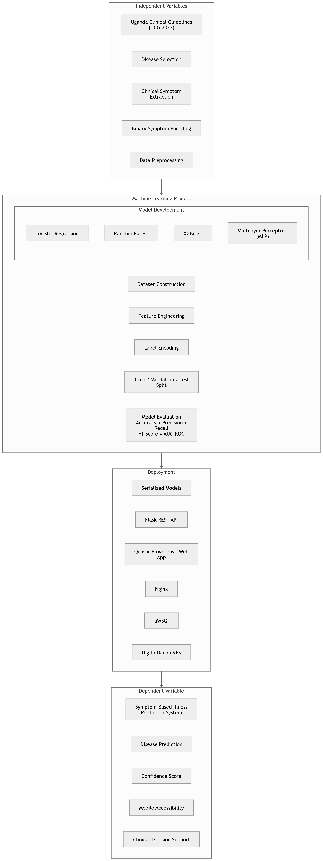
Figure 1. 1: Conceptual framework for the UCG-based illness prediction system

1.8 Study Limitations
The training data contained 4,616 repeated symptom–disease records, leaving only 304 unique records if all duplicates were removed. Retaining the repeated records preserved the number of optimization examples required by the implemented training procedure but did not increase the diversity of clinical presentations. The separate test set contained 42 records across 41 illness classes, which made class-level metrics sensitive to individual prediction errors.
The binary input representation omitted symptom severity, duration, onset, progression, and temporal relationships. It also excluded demographic variables, comorbidities, exposure history, geographic and seasonal prevalence, examination findings, vital signs, and laboratory results. Disease coverage was limited to conditions with sufficiently clear UCG profiles, while manual extraction created a risk of reviewer bias, inconsistent interpretation, and symptom omission. Consequently, the reported metrics demonstrate performance on the defined structured classification task and should not be generalized to real-world diagnostic performance without independent clinician review and clinical validation.

1.9 Significance of the Study
The study has local methodological significance because it documents how disease– symptom relationships extracted from Uganda’s national clinical guideline booklet were transformed into a structured machine learning dataset. This traceability provides a clearer local foundation than undocumented symptom mappings and makes the assumptions used during disease selection, symptom profiling, and binary case generation available for review.
The study also contributes comparative evidence on symptom-based multi-class classification. By evaluating neural, linear, bagging, and boosting models under consistent feature definitions, data partitions, and metrics, it shows whether increased model complexity produced a measurable advantage within the available structured feature space. The results therefore contribute to model-selection decisions for similar tabular classification tasks while also demonstrating the need to interpret high performance in relation to dataset construction and test-set size.
From an implementation perspective, the study demonstrates the engineering steps required to move from data-processing notebooks to a deployed prediction service. Preserving feature metadata and label encoders, implementing consistent inference preprocessing, exposing model endpoints, integrating a mobile-friendly frontend, and documenting the repository connect experimental modelling with operational deployment. The resulting system provides a reproducible technical foundation for future work involving clinician review, larger real-world datasets, external validation, explainability, privacy safeguards, and formal user evaluation.

1.10 Organization of the Report
Chapter 2 reviews literature on symptom-based classification, relevant model families, evaluation methods, deployment, and local clinical context. Chapter 3 describes the data, preprocessing, modelling, evaluation, API, frontend, and deployment methods. Chapter 4 presents and discusses the dataset, model, and application results. Chapter 5 provides the conclusions and recommendations, while Chapter 6 outlines future work. The references and supporting appendices follow the main chapters.

Chapter 2

Literature Review

2.1 Introduction
This chapter critically reviews literature relevant to symptom-based illness prediction and the deployment of machine learning models as accessible decision-support applications. The review is organized around symptom representation, local clinical relevance, comparative model families, reproducible data preparation, multi-class evaluation, and mobile or API-based deployment. Particular attention is given to the distinction between technical performance on structured datasets and clinical validity in real healthcare settings. The chapter concludes by identifying the methodological and implementation gap addressed by this research.
2.2 Symptom-Based Illness Prediction
Symptom-based illness prediction is commonly formulated as a supervised classification problem in which observed or reported symptoms are mapped to one of several disease classes. Pasi et al. describe the field as spanning structured symptom vectors, free-text descriptions, conventional machine learning, deep learning, natural language processing, and large language models [1]. This diversity reflects a central design choice: systems may prioritize flexible natural-language input or a constrained feature space that is easier to standardize and reproduce.
Sharma et al. reviewed symptom-driven disease risk assessment and emphasized the role of machine learning in identifying symptom patterns that may support early assessment and individualized health guidance [3]. Their review also considered natural language processing for interpreting unstructured clinical narratives. Such methods can capture richer descriptions than fixed symptom forms, but they introduce challenges involving vocabulary variation, ambiguity, preprocessing, and interpretation.
Vyas et al. developed a multi-disease classification framework based on naturallanguage symptom descriptions and compared Support Vector Machine, K-Nearest Neighbors, Decision Tree, Random Forest, and Extra Trees models [4]. Their findings indicate that ensemble classifiers can perform strongly when symptom descriptions are consistently preprocessed. However, their system used text normalization, lemmatization, n-grams, and term-frequency representations, whereas the present study used a predefined binary symptom matrix. The distinction matters because free-text systems offer flexibility to users but introduce linguistic ambiguity, while structured symptom selection provides consistent model inputs at the cost of restricting expression.
Avinash, Prabhu and Parthipan compared a multilayer perceptron with K-Nearest Neighbors for disease prediction from selected symptoms and reported stronger performance from the neural model [5]. Their findings support the ability of an MLP to learn nonlinear symptom–disease relationships. Nevertheless, the small experimental sample and limited comparison constrain conclusions about whether the neural model would retain its advantage over linear, bagging, or boosting methods on other structured datasets.
Taken together, these studies establish the feasibility of symptom-based classification but do not identify one universally superior representation or algorithm. Performance is influenced by how symptoms are defined, how labels are constructed, which comparators are selected, and whether evaluation cases are independent of the patterns used during training. These considerations justify evaluating multiple model families under a shared experimental procedure.

2.3 Uganda Clinical Guidelines and Local Clinical Relevance
The reliability of a symptom-based classifier depends on the quality, traceability, and contextual relevance of its symptom–disease mappings. The Uganda Clinical Guidelines 2023 are issued by the Ministry of Health as the national reference for the diagnosis and management of common health conditions [7]. They provide a common clinical vocabulary and nationally recognized descriptions of disease presentation, assessment, and management. Their use as a source for symptom mapping therefore offers a clearer Ugandan clinical foundation than an undocumented or exclusively imported mapping.
The importance of the UCG to this research extends beyond citing a local document.
The symptom–disease dataset used in the study was extracted from disease entries in the
Uganda Clinical Guidelines 2023 booklet and encoded as structured binary features. The guidelines reflect disease priorities, terminology, diagnostic considerations, and resource conditions within the Ugandan health system. They cover infectious diseases that remain important causes of morbidity as well as the increasing burden of non-communicable conditions [7]. Using this national reference reduced reliance on symptom–disease mappings derived entirely from external contexts and gave the dataset a clearer relationship to conditions recognized in routine Ugandan clinical guidance.
The UCG also offer a traceable basis for reviewing why a symptom is associated with a particular illness class. Guideline entries distinguish hallmark manifestations, supporting symptoms, associated clinical features, and related presentations that may require different interpretation. A dataset linked to these entries can therefore be audited against an identifiable source rather than treated as a collection of unexplained feature– label relationships.
Guideline-based extraction nevertheless requires an explicit methodology because a clinical narrative does not translate automatically into a machine learning row. Diseaseselection criteria, symptom terminology, distinctions between primary and supporting features, rules for generating partial or variant presentations, and checks for mutually exclusive variables all influence the resulting feature space. Documenting these decisions improves traceability, but manual interpretation can still introduce reviewer bias or omit clinical qualifiers. Independent review and agreement assessment are therefore important extensions for guideline-derived datasets.
Local representation remains important even when a nationally authoritative guideline is used. Kamulegeya et al. showed, in a Ugandan dermatology context, that model performance can deteriorate when development data do not adequately represent the population in which a system is applied [8]. Although their study concerned images rather than symptom vectors, the broader implication is relevant: contextual grounding improves relevance, but representative patient data and external validation remain necessary.
This form of guideline grounding does not by itself establish clinical validity. The UCG are written for professional interpretation alongside patient history, examination findings, laboratory investigations, and clinical judgment. Converting narrative guidance into binary features removes severity, chronology, uncertainty, and contextual qualifiers. A UCG-informed classifier should therefore be understood as a technical decision-support prototype rather than a digital substitute for the guidelines or for professional diagnosis.

2.4 Symptom Representation and Clinical Boundaries
Binary symptom encoding creates a uniform feature space that supports direct comparison across linear, tree-based, boosting, and neural models. It is computationally simple, interpretable at the input level, and compatible with browser-based symptom-selection interfaces. It can also represent partial presentations by assigning zero to symptoms that are absent from a constructed case.
These advantages are accompanied by important information loss. Binary variables do not represent severity, duration, chronology, progression, demographic characteristics, comorbidities, examination findings, laboratory results, or clinician observations. They also do not express the probability that a symptom occurs within a disease or the dependence among co-occurring symptoms. Pasi et al. identify incomplete data, explainability, and clinical reliability as persistent challenges in symptom-based classification [1]. Consequently, performance on a binary matrix demonstrates learning within a defined feature space but does not establish real-world diagnostic accuracy.
Clinical overlap further complicates interpretation. Common manifestations such as fever, fatigue, pain, vomiting, or headache may occur in several conditions, while the features that distinguish those conditions may depend on timing, severity, examination, or epidemiological context. A model may separate guideline-constructed patterns accurately while remaining uncertain when presented with incomplete, contradictory, or previously unseen patient information. Clinical boundaries must therefore be stated explicitly in both evaluation and deployment.

2.5 Comparative Machine Learning Models
Disease-prediction research employs a broad range of statistical, machine learning, and dataanalytics models, making systematic comparison important when selecting an approach for a particular clinical dataset [6]. Structured binary features may be sufficiently separable for a linear or tree-based classifier, whereas more complex interactions may favor boosting or a neural network. Comparing Logistic Regression, Random Forest, XGBoost, and an MLP therefore provides evidence across four distinct model families rather than assuming that model complexity guarantees superior performance.
Logistic Regression provides a probabilistic linear baseline for multi-class classification. It is computationally efficient and offers a useful benchmark for determining whether more complex non-linear models provide meaningful improvement. Random Forest combines multiple decision trees trained using bootstrap samples and randomized feature selection, reducing the variance associated with a single decision tree [9]. This makes it suitable for tabular datasets containing interactions among binary symptom variables.
XGBoost implements scalable gradient-boosted decision trees and includes regularization and optimization mechanisms designed for efficient learning from structured data [10]. Unlike Random Forest, which builds trees independently, boosting constructs trees sequentially to correct errors made by earlier trees. The method is therefore capable of learning complex interactions while retaining feature-importance measures that can support model interpretation.
The MLP provides a non-linear neural baseline. Its dense layers can learn interactions among symptoms that may not be captured by a linear classifier. The implementation used TensorFlow, an established platform for constructing and training machine learning models [11]. Dropout was used to reduce co-adaptation among hidden units [12], while batch normalization was used to stabilize optimization across hidden layers [13]. These techniques are particularly relevant where the number of model parameters is large relative to the number of unique training patterns.
The reviewed evidence therefore supports an empirical rather than complexity-driven approach to model selection. Linear, bagging, boosting, and neural methods should be compared using consistent data partitions and metrics because their relative performance depends on the structure, size, and clinical context of the available dataset [4], [6].

2.6 Data Preparation and Reproducible Modelling
Data preparation is central to reliable model comparison. Competing models should use the same feature definitions, label encoding, and data partitions so that performance differences arise from the models rather than from inconsistent preprocessing. Stratification can preserve class representation during development splits, while a separate test set reduces the risk of repeatedly adapting decisions to final evaluation cases.
Scikit-learn provides consistent interfaces for preprocessing, model fitting, and evaluation across conventional machine learning algorithms [14]. TensorFlow provides a flexible framework for constructing and training neural models [11]. Regardless of framework, reproducible deployment requires preservation of the trained model, label transformation, ordered feature definitions, and any preprocessing rules. Failure to preserve these artefacts can cause an inference request to differ silently from the representation used during training.
Duplicate records require careful interpretation. Removing all repeated rows may reduce redundancy but can leave too few examples for model training. Retaining repeated patterns increases the number of optimization updates but does not create additional clinical variation. For this reason, evaluation on unique and independent cases is more informative than performance on randomly held-out duplicates. This consideration is especially important when interpreting very high classification metrics from structured disease–symptom datasets.

2.7 Model Evaluation
Multi-class model evaluation should not rely on accuracy alone. Accuracy summarizes the proportion of correct predictions but can conceal uneven class performance. Precision measures the reliability of positive class predictions, recall measures the ability to identify relevant class instances, and the F1-score balances precision and recall. Sokolova and Lapalme show that the interpretation of classification measures depends on both the task structure and the averaging procedure [15].
Macro averaging gives each disease class equal weight and is therefore useful when class-level performance is important. Weighted averaging reflects class prevalence in the evaluation set. Confusion matrices and class-specific reports complement aggregate metrics by showing which diseases are confused. AUC-ROC can provide additional information when models produce class probabilities, although estimates based on very small per-class test samples should be interpreted cautiously.

2.8 Mobile and API-Based Deployment
Machine learning models have limited practical value if they remain confined to notebooks. Bhatt et al. found growing use of machine learning-enabled mobile health systems for prediction, monitoring, and early detection, while also emphasizing the importance of implementation context [2]. A mobile-friendly web application can increase accessibility because it can run in a browser without requiring users to install a platform-specific package.
An API-based architecture separates model inference from the user interface. This separation allows preprocessing, feature ordering, model loading, and label decoding to be controlled centrally while permitting different client applications to use the same prediction service. A Progressive Web Application can provide a mobile-friendly interface, while a production application server and reverse proxy can support reliable web access. However, deployment introduces additional requirements involving validation, security, privacy, usability, monitoring, and communication of model limitations.

2.9 Research Gap
Existing studies establish that symptom-based classification can be addressed using freetext processing, conventional classifiers, ensemble methods, and neural networks [3–5]. Reviews further show that disease prediction spans many algorithms and application settings [1], [6]. However, three related gaps remain. First, symptom mappings and generated cases are not always traceable to a locally authoritative clinical source. Second, very high metrics are often reported without sufficient discussion of duplicates, test-set size, missing clinical context, or external validation. Third, relatively few studies document the full engineering path from preprocessing and comparative evaluation to preserved inference artefacts, an API, and a deployed mobile-friendly interface.
The present research addresses this combined methodological and implementation gap by using the Uganda Clinical Guidelines 2023 as the documented source of the disease–symptom mappings, analysing the structure and limitations of the constructed dataset, comparing four model families under common partitions and metrics, preserving the artefacts required for inference, and deploying selected models through a Flask API and Quasar PWA. The contribution is a reproducible Uganda-grounded technical pipeline rather than a claim of autonomous diagnosis. Independent clinician review and validation on diverse real-world cases remain necessary before healthcare use.

Chapter 3

Materials and Methods

3.1 Introduction
This chapter describes the methodological procedures used to construct the UCG-derived symptom dataset, prepare and analyse the data, develop and evaluate the machine learning models, implement the prediction API and frontend, and deploy the completed system. It also documents the software environment, reproducibility measures, methodological limitations, and ethical boundaries of the work. Numerical findings and interpretation are reserved for Chapter 4.

3.2 Research Design
The study adopted an applied system-development and experimental machine learning design. The experimental component evaluated supervised multi-class classification using a common feature space, data partitions, and performance measures. The system development component operationalized selected models through preserved preprocessing artefacts, a Flask API, a Quasar PWA, and production server infrastructure. Combining these components enabled the research to assess both predictive performance and technical deployment feasibility.
The workflow proceeded through four sequential phases. The first phase covered UCG-based disease selection, symptom profiling, binary encoding, case generation, and consistency checking. The second phase covered data cleaning, exploratory analysis, feature engineering, label encoding, and partitioning. The third phase trained and compared an MLP, Logistic Regression, Random Forest, and XGBoost. The final phase serialized the selected artefacts, implemented prediction endpoints, integrated the Quasar PWA, and deployed the system on a VPS.
Figure 3.1 presents the complete machine learning pipeline. It shows the progression from the UCG source and disease selection through symptom extraction, binary encoding, dataset construction, cleaning, exploratory analysis, feature and label preparation, data splitting, comparative model development, evaluation, serialization, API integration, and PWA delivery. The diagram emphasizes that deployment depended on preserving the same feature definitions and preprocessing artefacts used during model development.

3.3 Data Sources and Clinical Foundation
The primary clinical source for constructing the symptom dataset was the Uganda Clinical Guidelines 2023 booklet [7]. The documented extraction process produced Training.csv, while Testing.csv provided a separate evaluation file organized under the same symptom feature and prognosis structure. The UCG were selected because they constitute Uganda’s standard clinical reference for the presentation, diagnosis, and management of common health conditions. Real Health Uganda describes the clinical guidelines as an evidence based and practical reference intended to support health workers in managing Uganda’s priority conditions and to promote nationally recognized standards of treatment [7]. Their use therefore provided a nationally relevant and reproducible basis for selecting diseases, identifying symptoms, and defining relationships between clinical features and illness classes.
The Real Health Uganda publication was used as a secondary contextual source concerning the purpose and national role of the updated UCG. The guideline booklet itself remained the authoritative source for disease selection, symptom extraction, clinical mapping, and page-level verification. This distinction prevented a descriptive web publication from being treated as the clinical basis of the constructed dataset.
The dataset represented each clinical presentation as a set of binary symptom indicators and one disease prognosis label. Each symptom column used a value of 1 to represent symptom presence and 0 to represent symptom absence. The prognosis column represented the target illness class for supervised classification.

3.4 Disease Selection Procedure
Diseases were selected according to four documented criteria: clinical significance within Uganda, regional prevalence, availability of sufficiently clear diagnostic descriptions in the UCG, and representation across major disease categories. The resulting scope included infectious diseases such as malaria, typhoid, hepatitis, tuberculosis, and dengue; non-communicable diseases such as diabetes, hypertension, and hypothyroidism; dermatological conditions such as fungal infection, psoriasis, impetigo, and acne; gastrointestinal disorders such as gastro-oesophageal reflux disease, peptic ulcer disease, and gastroenteritis; respiratory conditions such as bronchial asthma, common cold, and pneumonia; and neurological or musculoskeletal conditions such as migraine, arthritis, and cervical spondylosis. Urinary tract infection, heart attack, jaundice, and other clinically relevant conditions were also represented. This selection strategy sought breadth across common disease groups without claiming coverage of every condition described in the UCG.
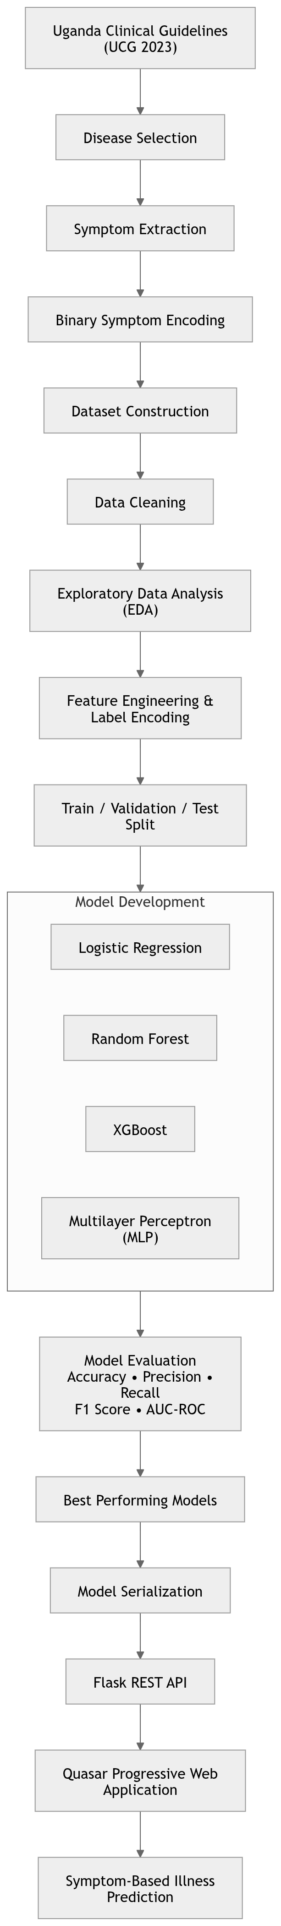
Figure 3. 1: Machine learning development and deployment pipeline

3.5 Symptom Identification and Clinical Mapping
Each selected disease was profiled through a structured review of its UCG entry. The review identified hallmark or highly indicative symptoms, supporting symptoms that contributed to the clinical picture, associated manifestations, and relevant risk or epidemiological indicators. A consistent terminology framework was then used to classify extracted features as primary symptoms, secondary symptoms, or associated clinical features. This distinction preserved the relative clinical role of each feature during documentation even though the final machine learning matrix represented all included features as binary variables.
The extraction also preserved distinctions between related clinical presentations when the UCG described a meaningful differentiating feature. Hypertensive emergency and hypertensive urgency illustrate this procedure. Both presentations included blood pressure greater than 180/110 mmHg, but the emergency profile required evidence of acute targetorgan damage, whereas the urgency profile explicitly represented its absence. Table 3.1 summarizes how this distinction informed the encoded symptom profiles.
Table 3. 1: Illustrative UCG-based extraction for hypertensive presentations
Presentation | Encoded distinction and representative features
Hypertensive emergency | Blood pressure above 180/110 mmHg with acute target-organ damage, represented by features such as severe headache, confusion, seizures, visual disturbance, acute chest pain, pulmonary oedema, acute kidney failure, and reduced urine output
Hypertensive urgency | Blood pressure above 180/110 mmHg without acute target-organ damage, with supporting features such as headache, dizziness, fatigue, epistaxis, and anxiety

3.6 Binary Encoding and Case Generation
The extracted information was transformed into a binary feature matrix in which each row represented one constructed clinical presentation, each symptom column indicated presence or absence, and the final prognosis column stored the disease class. Binary encoding was selected because it allowed a uniform tabular representation, supported direct application of multiple machine learning algorithms, and made it possible to represent partial presentations using subsets of the symptoms associated with a disease.
Multiple case rows were generated for each disease to represent variation within the documented profile. Full-presentation cases encoded all expected symptoms; partialpresentation cases omitted selected symptoms; variant cases represented different symptom groupings within the same disease; and atypical cases used less common combinations where these remained compatible with the UCG description. The case-generation procedure first identified all associated symptoms, then created full, partial, and atypical combinations, and finally checked each combination for clinical plausibility. In the hypertension example, one emergency case could emphasize neurological manifestations such as severe headache, confusion, seizures, and visual disturbance, while another could include cardiopulmonary or renal features. Urgency cases retained the absence-of-target-organ-damage indicator while varying supporting symptoms.

3.7 Internal Validation and Consistency Checks
Validation during dataset construction concerned source fidelity and internal consistency rather than evaluation on observed patients. Each disease–symptom pair was checked against its UCG entry, with regional epidemiological information and commonly recognized clinical presentations considered where available. Logical checks were used to prevent contradictory features from appearing within one profile, avoid co-encoding mutually exclusive symptoms in a single presentation, and maintain plausible relationships between symptoms and prognosis labels. These checks strengthened consistency of the constructed matrix but did not constitute independent clinical validation; such validation would require clinician review and real-world patient data.

3.8 Data Preparation and Exploratory Analysis

3.8.1 Data Wrangling Procedure
The data wrangling procedure was implemented using Python and Pandas. The workflow involved loading the training and testing datasets, inspecting sample records, checking dataset dimensions, reviewing column names, examining data types, identifying missing values, removing redundant columns, and checking duplicate records.
The column Unnamed: 133 was removed because it did not represent a valid symptom feature. Duplicate records were examined to determine whether they represented conflicting labels or repeated symptom–disease patterns. Since the duplicates represented repeated patterns rather than contradictory labels, they were retained for the implemented modeldevelopment procedure. Their interpretation was informed by the case-generation process: repeated rows increased the number of optimization examples but did not introduce new clinical variation. A total symptoms variable was then calculated as the row-wise sum of the 132 binary symptom columns. The detailed numerical results of these procedures are reported in Chapter 4.

3.8.2 Exploratory Data Analysis Procedure
Exploratory data analysis was conducted to understand the structure of the symptom-based dataset before model training. The analysis examined disease-class distribution, symptomfrequency patterns, correlation among common symptoms, and disease composition across symptom-frequency groups. Visualizations were produced using Matplotlib and Seaborn. These outputs were used to support interpretation of the dataset structure and to guide model development.

3.8.3 Feature and Label Preparation
The model input contained 132 binary symptom variables. An engineered symptom-count variable, stored as total symptoms, increased the model input to 133 features after removal of the empty column. The target variable was the prognosis label. Prognosis values were encoded using LabelEncoder; the encoder was fitted on the training labels and then applied to validation and test labels. For the MLP, the encoded labels were additionally converted into one-hot vectors because the network used a softmax output layer with categorical cross-entropy loss.
The order of the symptom columns was saved as feature columns.pkl. This was necessary because API inference requires incoming JSON symptom dictionaries to be converted into the same feature order used during training. Any missing symptom columns during inference were filled with zero to preserve the expected model input structure.

3.8.4 Data Splitting
The cleaned Training.csv data were divided into 85% training and 15% validation subsets using stratified random splitting with a random state of 42. Stratification preserved the prognosis-class distribution across the two development subsets. The separately supplied Testing.csv data were not included in this split and were reserved for final evaluation. The resulting training, validation, and test partitions were reused across all four model families to maintain a consistent comparison.

3.9 Model Development and Evaluation

3.9.1 MLP Model Development
The multilayer perceptron (MLP) was developed using TensorFlow and Keras [11]. Its input dimension matched the 133 model features. Four dense hidden layers containing 256, 128, 64, and 32 units used ReLU activation. Each hidden layer was followed by batch normalization and dropout of 0.3 to stabilize optimization and reduce overfitting [12], [13]. The output layer contained 41 softmax units corresponding to the illness classes.
The MLP was compiled using the Adam optimizer, categorical cross-entropy loss, and accuracy. Training used a maximum of 150 epochs and a batch size of 64. Three callbacks controlled the training process. ModelCheckpoint monitored validation accuracy and retained the best model. EarlyStopping monitored validation loss with a patience of 15 epochs and restored the best weights. ReduceLROnPlateau reduced the learning rate by a factor of 0.5 after five non-improving epochs, subject to a minimum rate of 10⁻⁶. The best neural-network model was saved as best mlp model.h5.

3.9.2 Traditional Machine Learning Models
Three traditional machine learning models were trained for comparison with the MLP: Logistic Regression, Random Forest, and XGBoost. Logistic Regression was configured for multinomial classification. Random Forest was used as an ensemble tree-based classifier [9]. XGBoost was configured for multi-class classification using gradient boosting [10].
Logistic Regression used the LBFGS solver, a maximum of 1,000 iterations, and a random state of 42. Random Forest used 200 estimators, a maximum depth of 15, parallel execution, and a random state of 42. XGBoost used 200 estimators, a maximum tree depth of 6, a learning rate of 0.1, the multi-class softmax objective, multi-class log-loss evaluation, and a random state of 42. The models were trained using the same feature matrix and encoded labels as the MLP workflow. XGBoost was serialized as best traditional model.pkl, and its label encoder was saved as label encoder traditional.pkl for decoding numeric predictions during API inference.

3.9.3 Model Evaluation Procedure
The models were evaluated using standard multi-class classification metrics [15]. Accuracy was used to measure the proportion of correct predictions. Macro precision, macro recall, and macro F1-score were used because they treat each disease class equally regardless of class frequency. Macro AUC-ROC was used to assess separability across classes where probability outputs were available.
Evaluation was performed once on the reserved test set after model development. Predicted probabilities were used to calculate macro one-versus-rest AUC-ROC where supported. Confusion matrices and classification reports were generated to examine class-level errors alongside the aggregate metrics. The evaluation results, comparative performance table, and interpretation are presented in Chapter 4.

3.10 System Implementation and Deployment

3.10.1 Overall System Architecture
The overall system used three connected layers. The presentation layer consisted of the Quasar PWA through which users selected symptoms and viewed prediction results. The application layer consisted of the Flask REST API, request validation, feature preprocessing, and MLP or XGBoost inference. The infrastructure layer consisted of the public domain, Nginx, uWSGI, serialized model artefacts, feature metadata, label encoders, and application logs hosted on the VPS. The frontend and backend interactions are detailed in Figures 3.3 and 3.2, while Figure 3.4 provides the overall physical and deployment view of the integrated system.

3.10.2 API Implementation
The backend API was implemented using Flask. The API loaded saved model artefacts, including the symptom feature-column order, the MLP label encoder, the traditional model label encoder, the Keras MLP model, and the serialized XGBoost model. Flask-CORS was used to allow the frontend application to communicate with the backend service.
A preprocessing function converted incoming JSON symptom instances into model-ready arrays. It created a Pandas DataFrame from the submitted dictionaries, added every missing model feature, assigned zero to missing values, reordered columns using feature columns.pkl, and returned a floating-point NumPy array. This procedure ensured that inference inputs matched the ordered representation expected by the trained models.
Figure 3.2 summarizes the backend request flow. A JSON request from the Quasar frontend enters the Flask REST API, undergoes validation and feature preprocessing, is converted to a DataFrame, and is reordered using the saved feature-column metadata. The resulting array is passed to the MLP, XGBoost, or combined inference route, after which labels and confidence scores are decoded and returned as a JSON response.

3.10.3 API Endpoints and Response Generation
The Flask application exposed four routes. The root route, /, used GET to document the API and its expected input format. Three POST routes handled inference: /predict mlp returned MLP predictions, /predict xgboost returned XGBoost predictions, and /predict all returned outputs from both deployed models. Each request was required to contain an instances key whose value was a non-empty list of symptom dictionaries. For each model, the class with the highest probability was decoded into a disease label, the maximum probability was reported as the confidence score, and the result was returned as JSON. Invalid requests produced an explanatory client-error response, while unexpected inference failures produced a server-error response.

3.10.4 Frontend PWA Development
The frontend was developed using Quasar as a Progressive Web Application framework. The PWA provided a browser-based interface through which users could submit symptom information and receive prediction outputs. The frontend communicated with the Flask API using JSON requests and displayed model responses in a mobile-friendly format.
As shown in Figure 3.3, the frontend architecture separated user interaction, symptom selection, API communication, and prediction display. The user supplied symptoms through the Quasar interface, the Axios service sent the structured request to the Flask API, and the returned prediction response was rendered by the result component. This separation kept presentation logic distinct from backend preprocessing and inference.
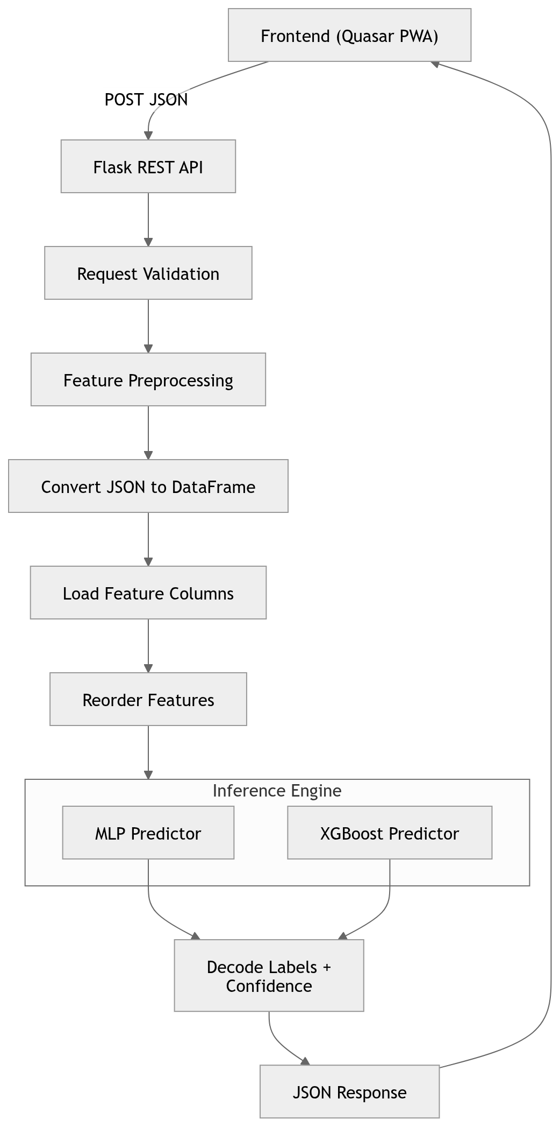
Figure 3. 2: Backend API architecture and inference flow
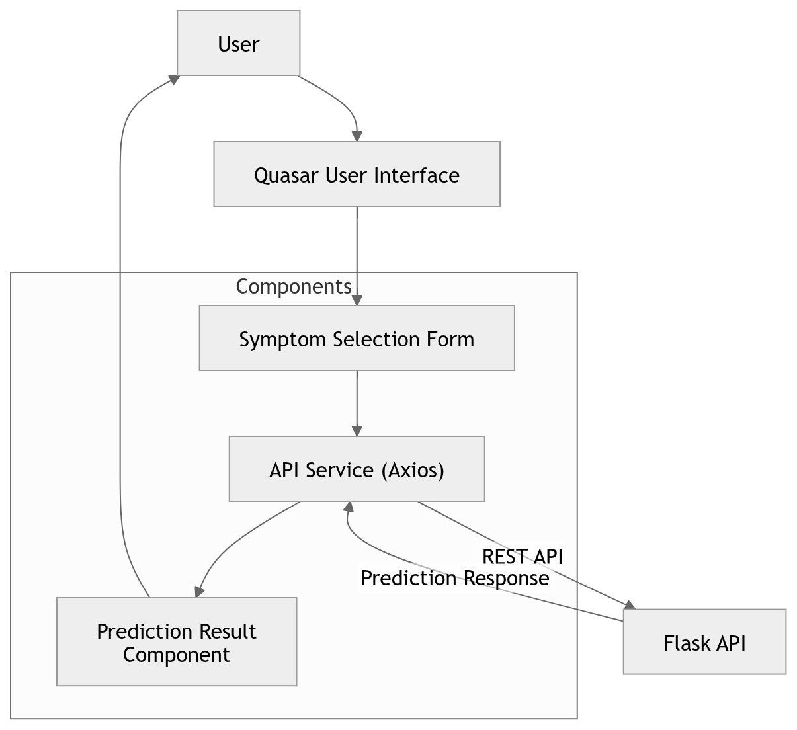
Figure 3. 3: Frontend architecture of the Quasar PWA

3.10.5 Deployment Procedure
The system was deployed on a DigitalOcean Droplet VPS. The Flask API was served using uWSGI, while Nginx was configured as a reverse proxy for API traffic. Nginx was also used to serve the built Quasar PWA frontend. This deployment architecture allowed the trained models to be accessed through a web API and consumed by the frontend application.
Figure 3.4 presents the production deployment architecture. Requests arriving through the public domain were handled by Nginx, which served the static Quasar PWA and proxied API traffic to uWSGI. uWSGI hosted the Flask application, while the API accessed the serialized models, feature metadata, label encoders, and application logs required for inference and operational monitoring.
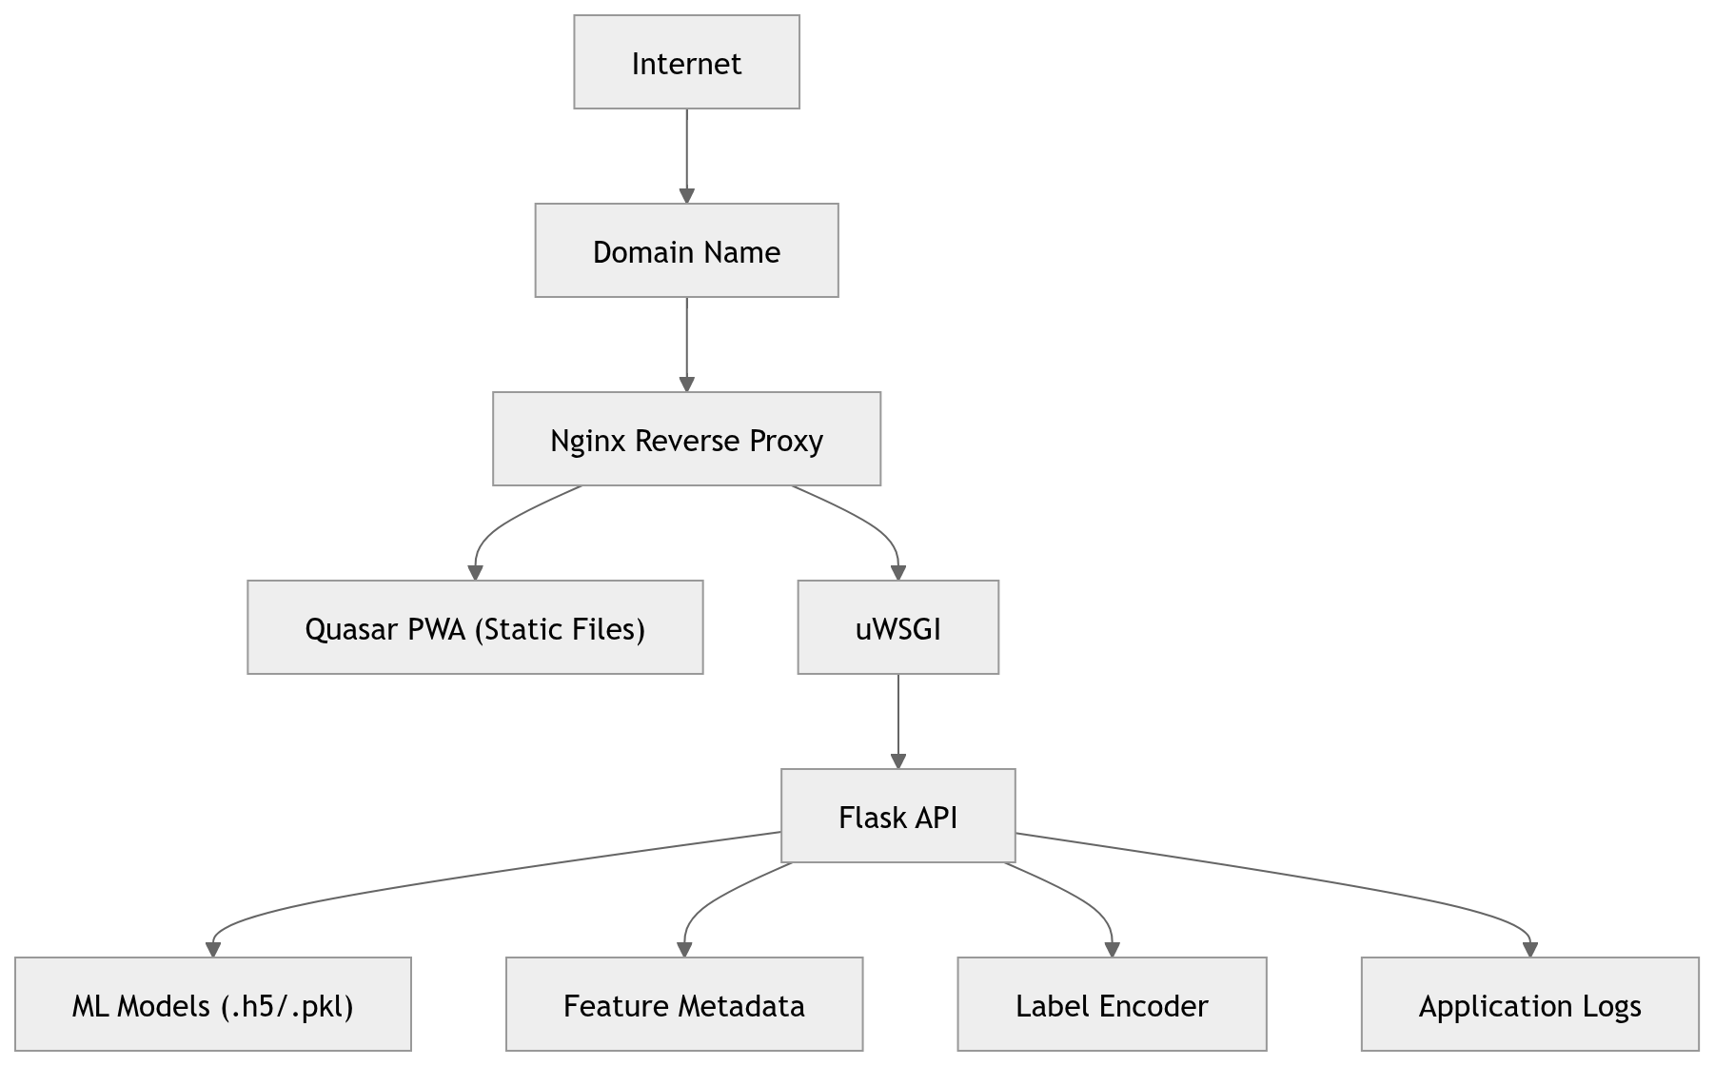
Figure 3. 4: Overall System and Production deployment Architecture

3.11 Software and Tools
The main programming language used was Python. Data handling and preprocessing were performed using Pandas and NumPy. Visualization was performed using Matplotlib and Seaborn. Conventional machine learning models were developed using Scikit-learn [14], while the MLP used TensorFlow/Keras [11]. XGBoost was used for gradient-boosted tree modelling [10]. The backend was implemented using Flask and Flask-CORS. The frontend was implemented using Quasar. Deployment used Nginx, uWSGI, and a DigitalOcean Droplet VPS.

3.12 Research Code and Reproducibility
The source code supporting the research is maintained in a public GitHub repository: https://github.com/ayikomike/Symptom-Based-Illness-Prediction. The repository contains the data-wrangling and exploratory-analysis notebooks, model-training and evaluation workflow, Flask API, and related implementation artefacts. Reproducibility was further supported by the use of a fixed random state for partitioning and conventional models, common data partitions for model comparison, saved feature-column order, preserved label encoders, serialized trained models, and documented inference preprocessing.

3.13 Methodological Limitations of the Extracted Dataset
The extraction methodology imposed several limitations on the resulting dataset. Disease coverage was restricted to conditions with sufficiently clear symptom descriptions and therefore excluded unmodeled, rare, emerging, or highly variable multisystem diseases. The selected UCG profiles may not contain every rare or recently recognized manifestation of an included condition. Consequently, the trained models cannot predict diseases outside the defined prognosis classes and may be less sensitive to presentations that differ substantially from the encoded profiles.
Binary encoding also removed gradation and sequence. A value of 1 indicated that a feature was present but did not distinguish mild from severe manifestations, acute from chronic duration, or early from late presentation. The matrix did not encode symptom order, progression, or probabilistic dependence, even though symptoms often co-occur and interact in clinically meaningful ways. Shared features across diseases may therefore be difficult to resolve without temporal, examination, or laboratory information.
The dataset further omitted demographic characteristics, comorbidities, occupation, travel and exposure history, regional prevalence, and seasonal patterns. These variables affect prior disease probability and the expression of illness in real populations. Manual extraction and case generation could additionally introduce reviewer bias, inconsistent terminology, or overlooked symptoms. Internal source and logic checks reduced obvious errors but did not quantify inter-reviewer agreement or establish generalizability across patient groups.

3.14 Ethical Considerations
The research used a guideline-constructed dataset rather than identifiable patient records and did not involve recruitment of human participants. The deployed system was designed as a preliminary decision-support prototype and not as a replacement for professional clinical diagnosis. Users should consult qualified healthcare professionals before making health decisions based on its outputs. Because symptom submissions may constitute sensitive health information, any extension beyond technical demonstration should include clear consent mechanisms, privacy notices, secure transmission, access controls, and defined data-retention practices.
These methodological limitations also affect ethical interpretation. A prediction generated from an incomplete binary profile may appear more definitive than the underlying evidence permits, particularly when disease prevalence and patient context are unavailable. The interface should therefore communicate uncertainty and the restricted scope of modeled diseases. The system should be interpreted as a technical prototype for symptombased decision support, and broader clinician review and validation with real-world data are required before practical healthcare use.

Chapter 4

Results and Discussion

4.1 Introduction
This chapter presents and discusses the results of UCG-based dataset construction, data preparation, exploratory analysis, comparative model evaluation, and application deployment. Quantitative findings are reported alongside interpretation of the dataset’s construction characteristics, the small class-level test support, and the distinction between technical prediction performance and clinical validity. The discussion is aligned with the study objectives and the methodological boundaries established in Chapter 3.

4.2 Dataset Construction Results
The UCG-based extraction produced a structured disease–symptom matrix spanning infectious, non-communicable, dermatological, gastrointestinal, respiratory, neurological, musculoskeletal, and other clinically relevant conditions. Disease inclusion was therefore not based only on the availability of machine-readable examples; it followed documented criteria concerning clinical importance in Uganda, regional prevalence, clarity of the UCG description, and representation across disease categories. This process yielded 41 prognosis classes and established a traceable clinical source for the features associated with each class.
The symptom-profiling stage distinguished primary symptoms, secondary symptoms, associated clinical features, and relevant epidemiological or risk indicators before converting the selected variables into binary form. The resulting matrix could represent more than one presentation of the same disease. Full cases contained the expected symptom set, partial cases contained a clinically plausible subset, and variant or atypical cases represented alternative patterns compatible with the relevant guideline entry. This construction strategy increased the range of encoded combinations available for model training, although it could not reproduce the variability of prospectively observed patients.
Appendix B presents an illustrative record from the symptom dataset extracted from the UCG. The example shows how a constructed UCG-derived presentation was stored as a binary feature vector: four symptom indicators were assigned a value of 1, the remaining 128 symptom variables were assigned 0, and the prognosis column contained the corresponding illness class.
The hypertension profiles demonstrate the outcome of this method. Hypertensive emergency and hypertensive urgency shared the indicator for blood pressure greater than
180/110 mmHg, but they were differentiated by evidence of acute target-organ damage. Emergency profiles included manifestations such as confusion, seizures, visual disturbance, acute chest pain, pulmonary oedema, acute kidney failure, or reduced urine output, whereas urgency profiles retained the explicit absence of target-organ damage and could include headache, dizziness, fatigue, epistaxis, or anxiety. This example shows that the extraction attempted to preserve clinically meaningful distinctions through combinations of features rather than treating every elevated blood-pressure presentation as the same class.
Internal source and logic checks supported consistency of the constructed profiles. Disease–symptom pairs were checked against the UCG, contradictory or mutually exclusive features were not intentionally placed in the same case, and generated combinations were reviewed for plausibility. These outcomes indicate that the dataset was systematically constructed, but they should not be interpreted as external clinical validation because no comparison with independently observed patient encounters was undertaken.

4.3 Dataset Preparation Results
The documented UCG extraction was stored in Training.csv, which contained 4,920 constructed records and 134 columns before cleaning. These columns comprised 132 raw symptom variables, one prognosis label, and one empty column. Each of the 41 prognosis classes contained exactly 120 records, indicating a deliberately balanced constructed dataset rather than an observed prevalence distribution. After removal of the empty column and addition of the row-wise symptom count, the model input contained 133 features. The separately supplied Testing.csv file contained 42 records under the same feature structure. The final partitions comprised 4,182 training samples, 738 validation samples, and 42 test samples.
Missing-value inspection showed that the redundant empty column contained 4,920 missing entries, while the cleaned dataset contained no missing values. Duplicate analysis identified 4,616 repeated rows in the training data, leaving 304 unique symptom–disease records. The same number of repeated symptom patterns was observed when the disease label was ignored, indicating repetition rather than conflicting labels. These rows were retained because the reduced set of unique combinations was too small for the implemented 41-class training procedure. The test file contained no duplicate symptom patterns; it therefore assessed prediction on unique encoded cases, although its 42 records did not provide evidence of generalization to real clinical populations.
Table 4. 1: Summary of dataset preparation results
Dataset property | Result
Initial training records | 4,920
Initial columns | 134
Raw symptom variables | 132
Engineered model features | 133
Disease classes | 41
Records per training class | 120
Training samples | 4,182
Validation samples | 738
Test samples | 42
Duplicate training rows | 4,616
Unique training rows | 304
Duplicate test symptom patterns | 0

The cleaning results show that the UCG-extracted dataset was structurally consistent after removal of the empty column. The high number of duplicate rows must nevertheless be interpreted in relation to the documented case-generation strategy. Full, partial, variant, and atypical cases were generated from finite disease profiles, making recurrence of the same binary pattern possible. Repeated rows increased the effective number of optimization examples but did not add new symptom combinations. Strong model performance may therefore reflect both genuine separability among the encoded UCG profiles and the regularity introduced by constructing cases from predefined mappings.

4.4 Exploratory Data Analysis Results
Exploratory data analysis examined illness distribution, symptom frequency, symptom count, and co-occurrence. Figure 4.1 confirms that every prognosis class contained 120 training records. This exact balance prevented class-frequency dominance during model fitting, but it should not be interpreted as epidemiological prevalence because the records were generated from UCG profiles rather than sampled from a patient population.
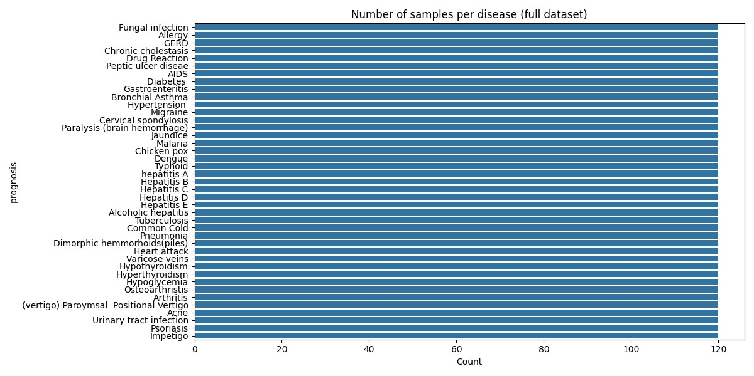
Figure 4. 1: Number of samples per disease in the full dataset
Figure 4.2 presents the frequency distribution of the 132 raw symptoms. Fatigue was the most frequent indicator, occurring in 1,932 records, followed by vomiting in 1,914, high fever in 1,362, loss of appetite in 1,152, and nausea in 1,146. The broad distribution confirms that several supporting symptoms were shared across disease profiles. Such symptoms have limited discriminatory value in isolation and become informative mainly through combinations with more disease-specific features.
The correlation analysis in Figure 4.3 further demonstrates structured co-occurrence among common symptoms. The strongest correlation among the 20 most frequent symptoms was between loss of appetite and yellowing of the eyes (r = 0.768). Other strong relationships included abdominal pain with yellowish skin (r = 0.733), yellowish skin with yellowing of the eyes (r = 0.715), and chest pain with cough (r = 0.678). These patterns are consistent with case generation from disease-specific profiles, but they also show that symptom independence would be an unrealistic assumption.
The raw number of positive symptoms per training record ranged from 3 to 17, with a mean of 7.45 and a median of 6. Figure 4.4 shows how diseases drew on symptoms from different frequency groups. Chronic cholestasis, hepatitis A, Hepatitis D, jaundice, heart attack, and malaria relied entirely on features in the highest-frequency group, whereas AIDS and acne derived 75% of their represented symptoms from the lowest-frequency group. The engineered total symptoms feature summarized case density but did not represent clinical severity.

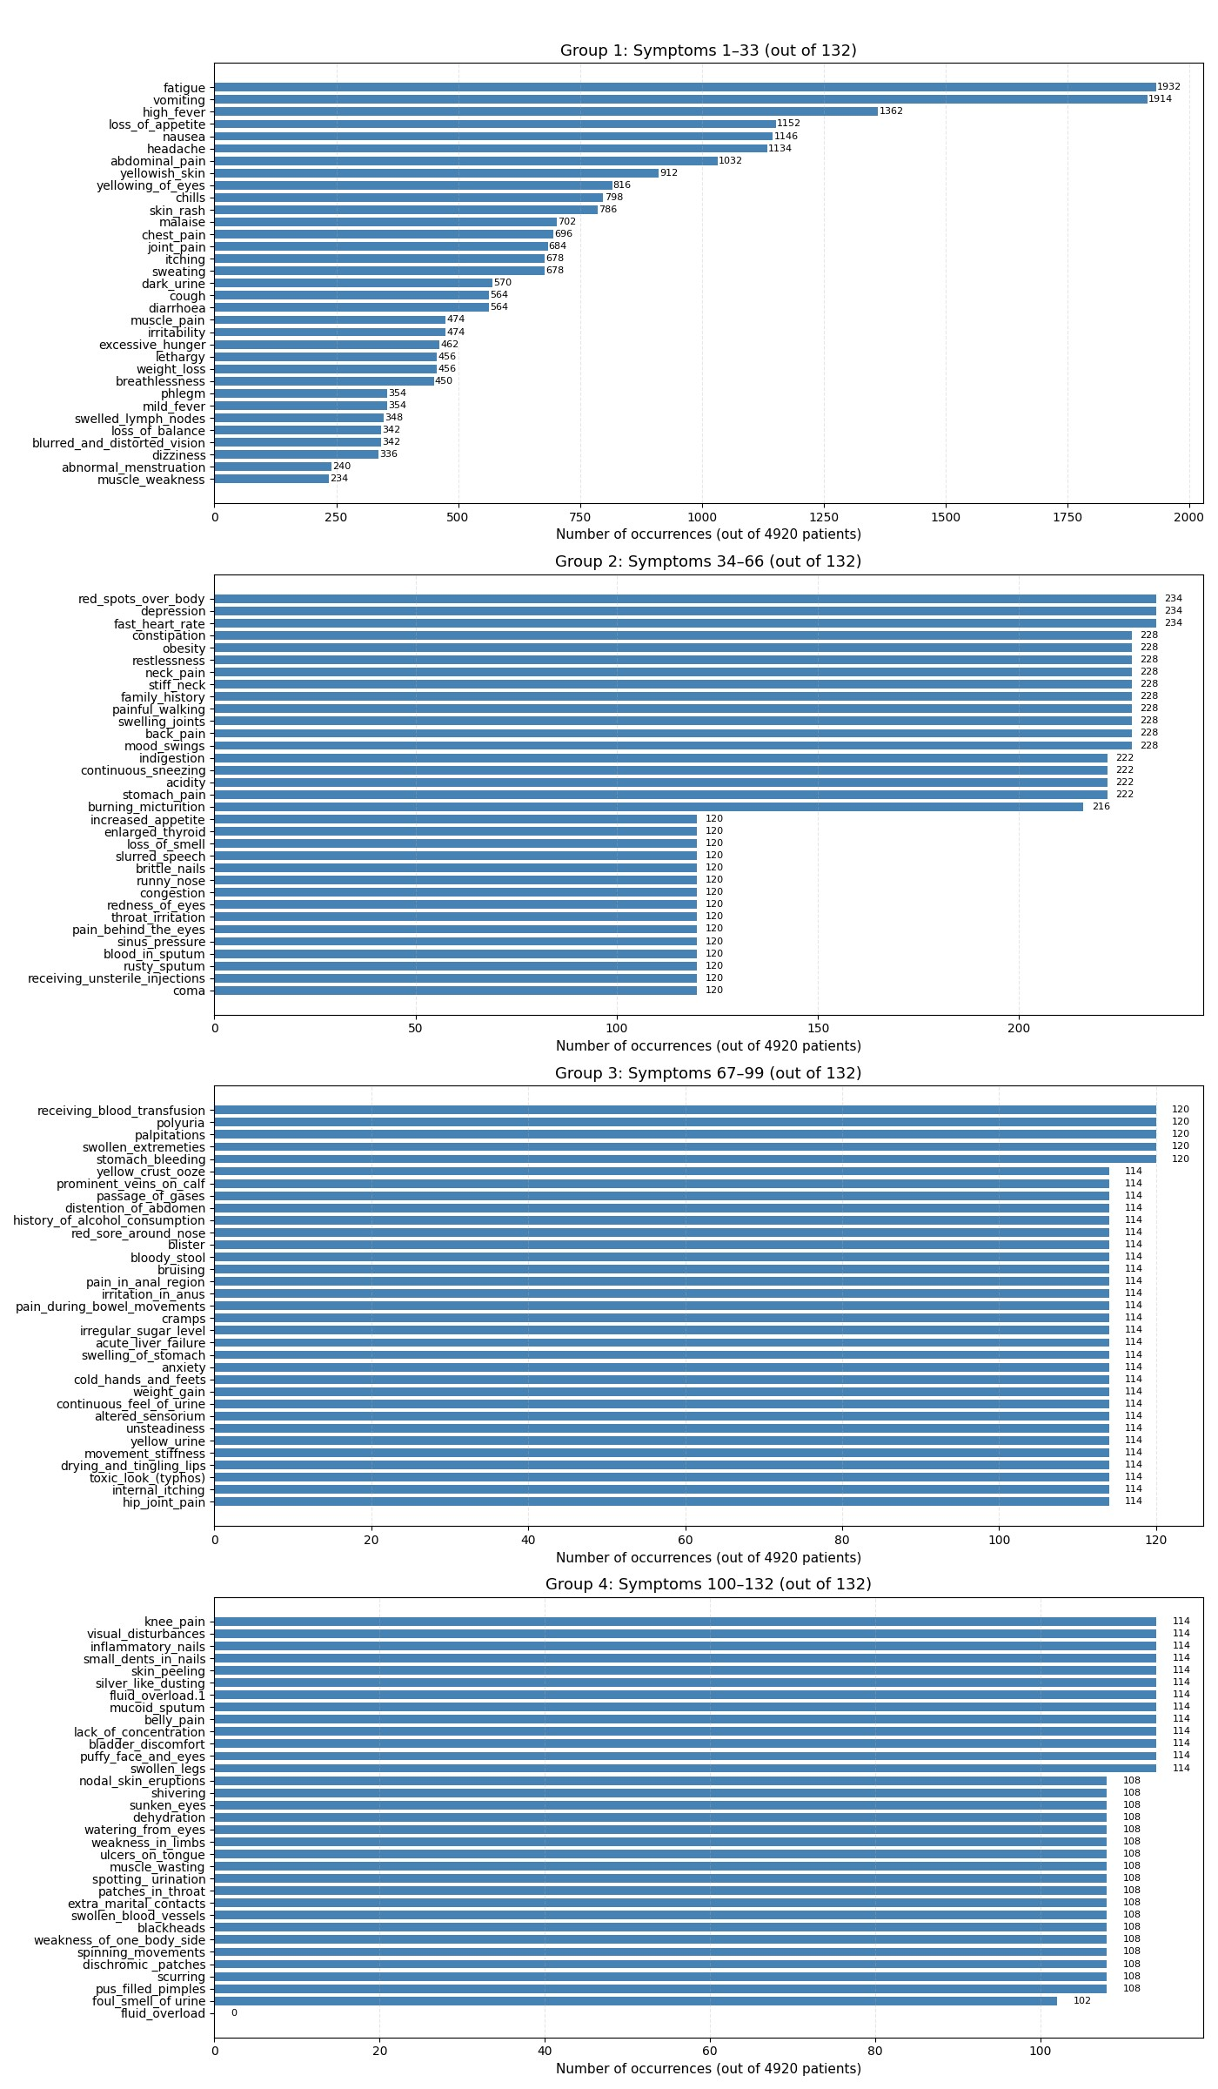
Figure 4. 2: Symptom frequency distribution in the full dataset
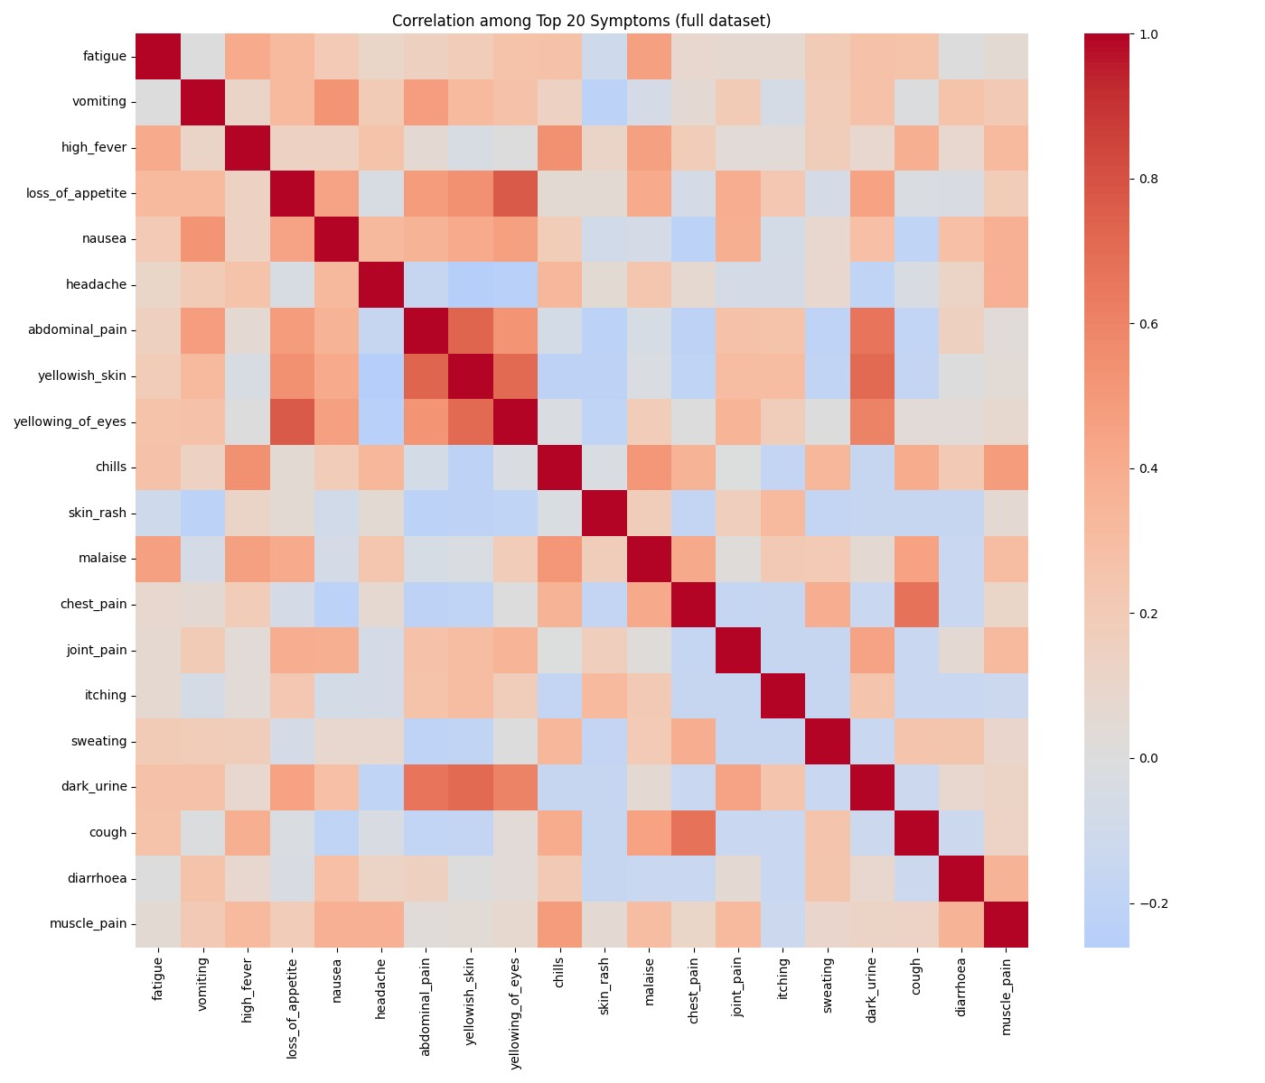
Figure 4. 3: Correlation among the top 20 symptoms
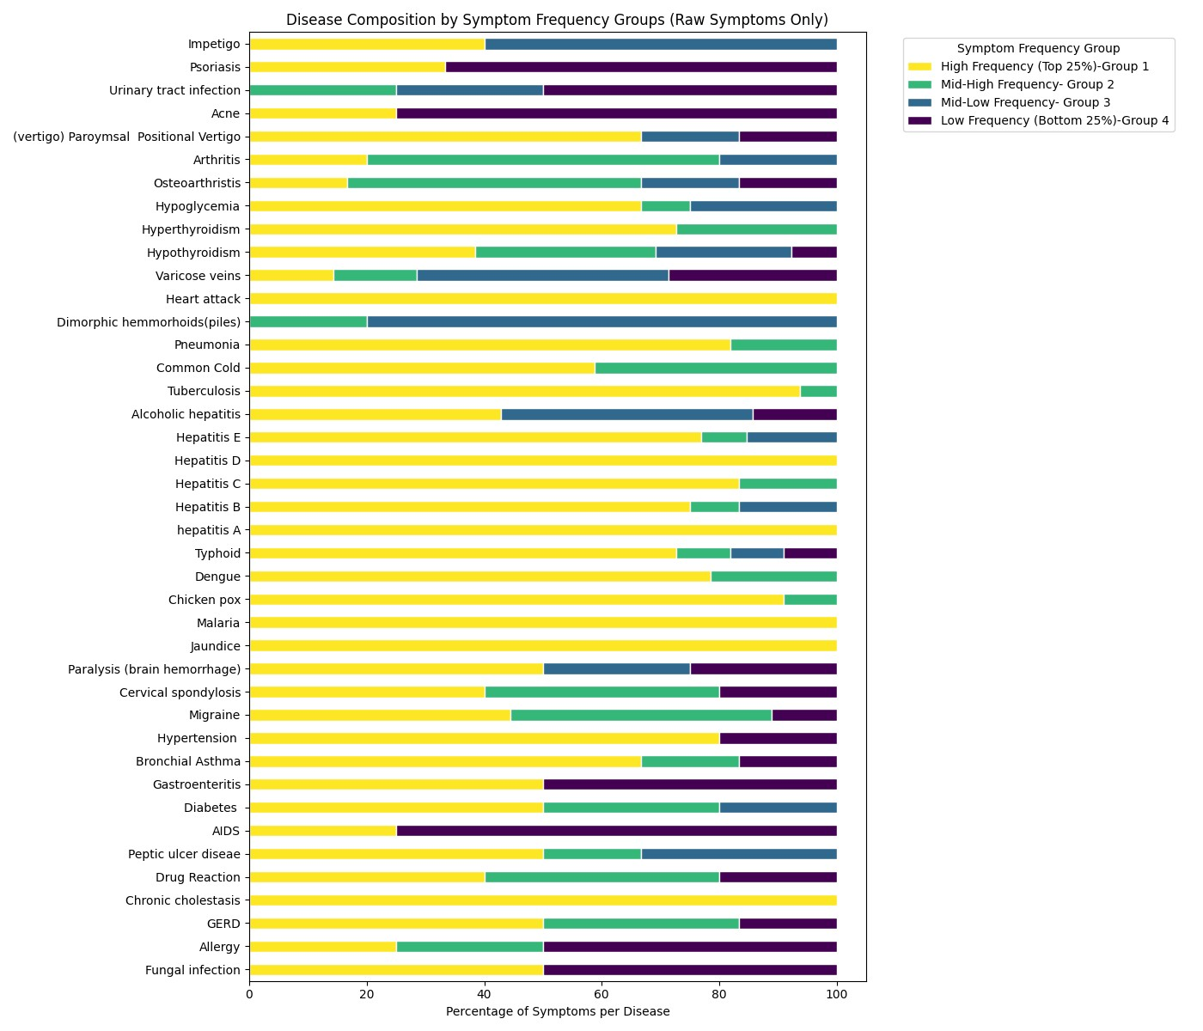
Figure 4. 4: Disease composition by symptom-frequency groups

4.5 Comparative Model Evaluation Results
Four models were evaluated: an MLP, Logistic Regression, Random Forest, and XGBoost. All models used the same 133 features and the same training, validation, and test partitions. This controlled comparison ensured that differences in performance were attributable to model behavior rather than inconsistent preprocessing or evaluation data.
The MLP achieved 97.62% accuracy on the 42-sample test set, with macro precision of 98.78%, macro recall of 98.78%, macro F1-score of 98.37%, and macro AUC-ROC of 99.36%. Logistic Regression, Random Forest, and XGBoost each achieved the same test accuracy of 97.62%, macro precision of 98.78%, macro recall of 98.78%, and macro F1-score of 98.37%. Their reported macro AUC-ROC values were 100%.
Table 4. 2: Comparative model performance on the test set
Model | Accuracy | Precision | Recall | F1-score | AUC-ROC
MLP | 0.9762 | 0.9878 | 0.9878 | 0.9837 | 0.9936
Logistic Regression | 0.9762 | 0.9878 | 0.9878 | 0.9837 | 1.0000
Random Forest | 0.9762 | 0.9878 | 0.9878 | 0.9837 | 1.0000
XGBoost | 0.9762 | 0.9878 | 0.9878 | 0.9837 | 1.0000

All four models correctly classified 41 of the 42 test records. Their identical accuracy and macro F1-score indicate that the available test set did not distinguish the predictive capability of the four model families. The result suggests that the UCG-derived feature space was highly structured and separable, allowing linear, bagging, boosting, and neural approaches to learn nearly the same class boundaries.
The AUC-ROC values require particular caution. Forty of the 41 classes had only one test example, while fungal infection had two. Under this structure, one-versus-rest ranking can produce apparently perfect AUC values even when a model makes a class-label error. The 1.0000 AUC reported for the conventional models should therefore not be interpreted as conclusive evidence of perfect class separation. The broader finding remains consistent with comparative disease-prediction literature showing that relative model advantage depends on data representation, comparator choice, and evaluation design [4], [6].

4.6 MLP Training and Error Analysis
The MLP training procedure ended after 103 of the maximum 150 epochs. Validation accuracy reached 100% at epoch 3 and remained at that level, while validation loss continued to decline and reached its minimum near epoch 88. The learning-rate scheduler progressively reduced the rate to 10⁻⁶. The sustained perfect validation accuracy is consistent with the regular and repeated structure of the development data and should not be interpreted as evidence of equivalent performance on independent clinical cases.
Figure 4.5 presents the training and validation curves. Training accuracy increased from 27.76% in the first epoch to approximately 99.95% by the final epoch, while validation accuracy reached 100% early in training. The corresponding loss curves declined substantially. Dropout, batch normalization, checkpointing, early stopping, and learning-rate reduction controlled the optimization process, but the near-perfect validation curve also reflects that the validation subset came from the same repeated-pattern training source.
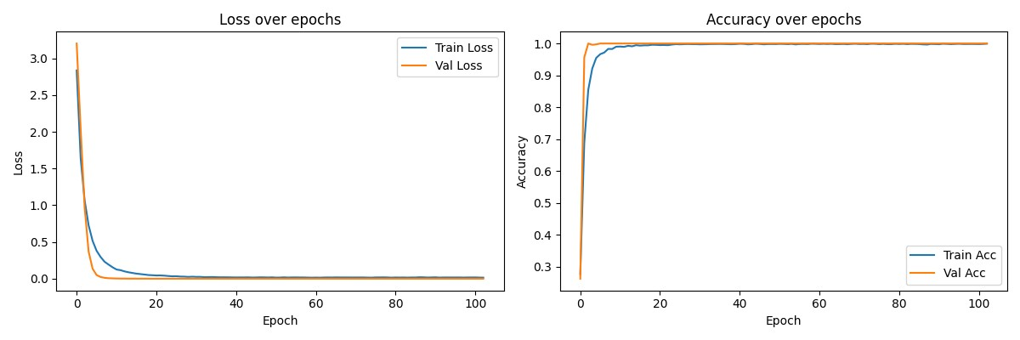
Figure 4. 5: MLP training history
The MLP confusion matrix in Figure 4.6 shows one error: one of the two fungalinfection records was classified as psoriasis. Fungal infection therefore had recall of 0.50 and an F1-score of 0.6667, while psoriasis had precision of 0.50 and an F1-score of 0.6667. All remaining test records were classified correctly. Because most classes had support of only one, these class-level values are highly sensitive to a single prediction.

4.7 XGBoost Error Analysis and Feature Importance
XGBoost achieved the same overall accuracy and macro F1-score as the MLP but made a different error. As shown in Figure 4.7, one of the two fungal-infection records was classified as chicken pox. Fungal infection consequently had recall of 0.50, while chicken pox had precision of 0.50. The difference between the MLP and XGBoost errors indicates that equivalent aggregate metrics can conceal different class-confusion patterns.
Figure 4.8 shows the relative importance assigned to input features by XGBoost. The figure provides a model-level indication of which variables contributed most to tree construction, but it does not show why a particular individual prediction was made or establish that the learned importance is clinically appropriate. The ranking should therefore be treated as an exploratory transparency measure requiring comparison with the UCG mappings and clinician interpretation.
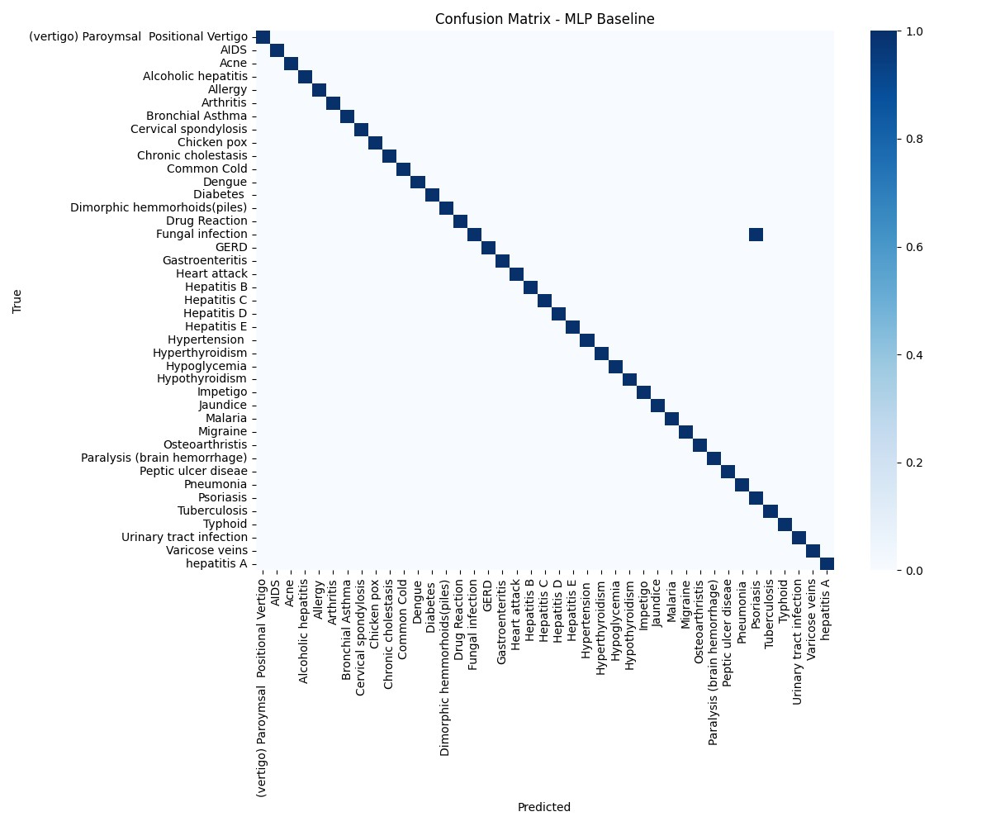
Figure 4. 6: Confusion matrix for the MLP model
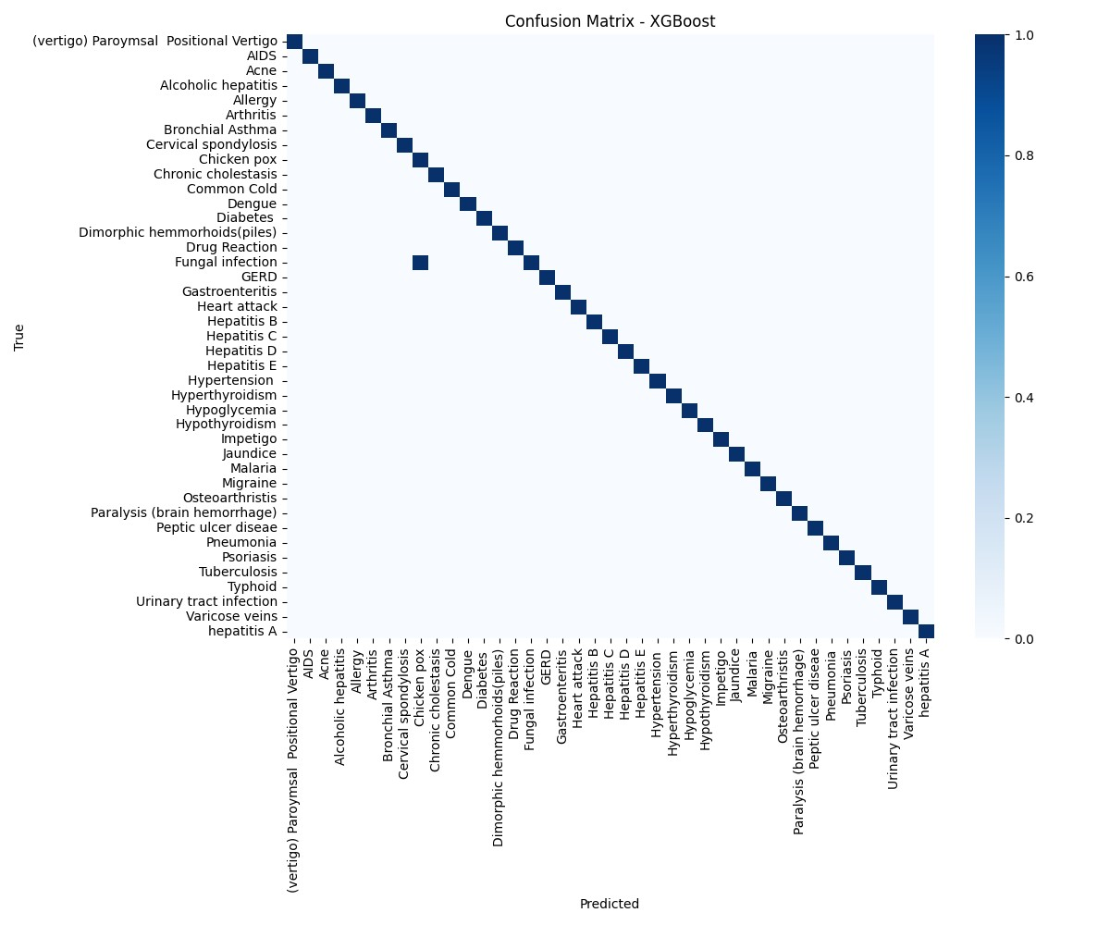
Figure 4. 7: Confusion matrix for the XGBoost model
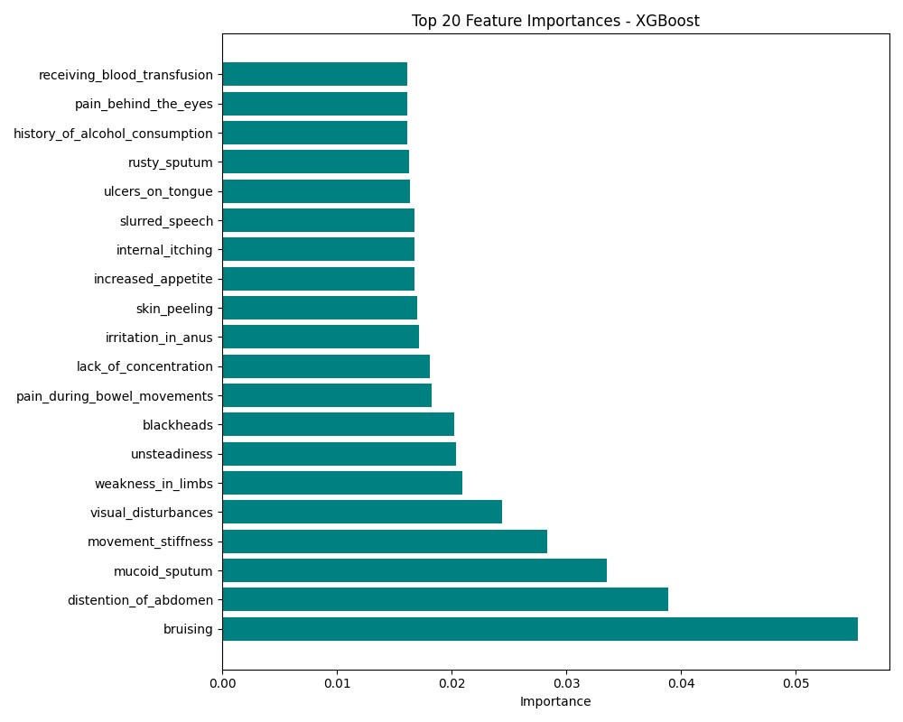
Figure 4. 8: XGBoost feature importance

4.8 Application Deployment Results
The implementation extended beyond offline modelling by exposing the serialized MLP and
XGBoost models through Flask endpoints and integrating the returned predictions into a mobile-friendly Progressive Web Application. Figure 4.9 shows the deployed interface displaying a disease prediction and confidence score. This result confirms functional integration of the frontend, API preprocessing, model inference, label decoding, and response display.
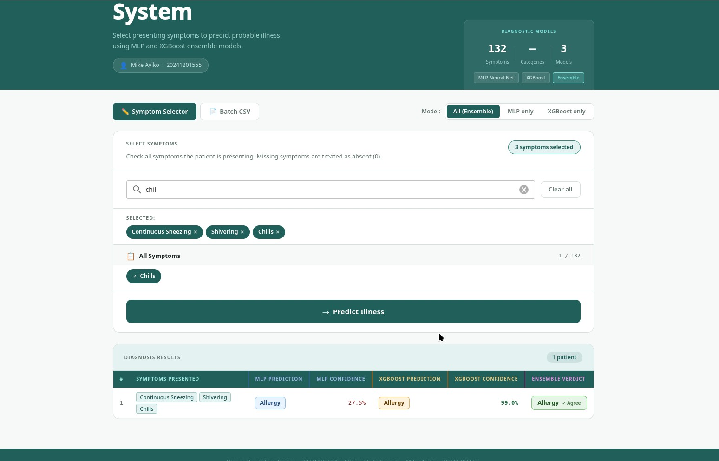
Figure 4. 9: PWA prediction interface
The deployment achieved the study’s technical implementation objective by demonstrating an end-to-end pathway from saved preprocessing metadata and models to user-facing prediction. However, this result was a functional demonstration rather than a formal assessment of usability, security, response time, reliability, clinical workflow integration, or user comprehension.

4.9 Integrated Discussion
The findings demonstrate that all four models learned the structured UCG-derived symptom patterns and that the selected MLP and XGBoost artefacts could be operationalized through a Flask API and PWA. The equality of the aggregate metrics shows that increased model complexity did not provide a measurable advantage on the 42-record test set. This outcome supports empirical model comparison rather than assuming that a neural network will outperform conventional approaches on a highly structured tabular feature space.
The balanced training distribution prevented majority-class dominance, but the duplicate analysis showed that balance was achieved through repeated constructed patterns rather than broad clinical diversity. Similarly, the unique test patterns reduced direct duplicate leakage into evaluation, but 42 records were insufficient for stable assessment across 41 classes. The reported metrics therefore describe performance on the encoded guideline task and not sensitivity, specificity, or calibration in a patient population.
The UCG origin is a methodological strength because it makes the mappings locally identifiable and auditable. It is simultaneously a limitation because guideline descriptions are not observed patient records, manual extraction may introduce interpretation bias, and binary encoding removes severity, duration, progression, demographics, comorbidity, examination findings, laboratory evidence, and epidemiological context. The internal checks reduced obvious contradictions but did not measure agreement among independent clinicians or diagnostic performance in practice.
Overall, the study achieved technical feasibility rather than clinical validation. The dataset was constructed and analysed, four models were compared consistently, deployment artefacts were preserved, and two models were served through an operational web application. The system should remain a preliminary decision-support prototype until the extraction is independently reviewed, probability outputs are calibrated on larger data, and performance is evaluated using diverse clinician-confirmed Ugandan cases.

Chapter 5

Conclusion and Recommendations

5.1 Introduction
This chapter presents the conclusions drawn from the UCG-based dataset construction, exploratory analysis, comparative model evaluation, and system deployment. It also provides recommendations that follow directly from the methodological limitations and empirical findings reported in Chapter 4. The conclusions are restricted to the implemented structured classification task and do not claim clinical diagnostic validity.

5.2 Conclusion
The first objective was achieved through construction and documentation of a symptom– disease dataset derived from the Uganda Clinical Guidelines 2023 [7]. Diseases were selected using clinical relevance, regional importance, clarity of guideline description, and category representation. Their profiles were translated into primary symptoms, secondary symptoms, associated features, and relevant risk indicators before full, partial, variant, and atypical cases were encoded. This procedure made the mappings traceable to Uganda’s national clinical reference, although source and logic checks did not replace independent clinician validation.
The data-preparation and exploratory objectives were also achieved. The training data contained 4,920 records, 132 raw symptom variables, and 41 equally represented classes with 120 records each. Removal of the empty column and addition of the symptom-count variable produced 133 model features. The final partitions comprised 4,182 training records, 738 validation records, and 42 separate test records. Fatigue and vomiting were the most frequent symptoms, several clinically related features showed strong co-occurrence, and records contained between 3 and 17 positive symptoms. However, 4,616 records were duplicates, leaving only 304 unique training patterns. The balanced class distribution and repeated patterns therefore reflected dataset construction rather than disease prevalence or broad clinical diversity.
The comparative modelling objective showed that the MLP, Logistic Regression, Random Forest, and XGBoost each classified 41 of the 42 test records correctly. All four achieved 97.62% accuracy, 98.78% macro precision, 98.78% macro recall, and 98.37% macro F1-score. Increased model complexity therefore produced no measurable advantage on the available test set. The reported AUC-ROC values were high, but their interpretation was limited because 40 classes had only one test example and one error materially altered class-level metrics.
The implementation objectives were achieved by preserving the feature order, label encoders, MLP model, and XGBoost model and operationalizing them through a Flask API and Quasar PWA. The deployed system accepted symptom selections, transformed them into the required feature order, generated model predictions and confidence scores, and displayed the responses through a mobile-friendly interface. This demonstrated technical continuity from UCG extraction and model development to reproducible webbased inference.
Overall, the study achieved its purpose as an applied machine learning and deployment project. It established that a UCG-grounded binary feature space could support highly accurate classification of the defined encoded cases and that selected models could be delivered through an operational application. The findings do not establish clinical diagnostic effectiveness. The UCG requires interpretation alongside patient history, examination, investigations, prevalence, and professional judgment, while the implemented data omitted much of this context. The system should therefore remain a technically evaluated decision-support prototype rather than a diagnostic authority.

5.3 Recommendations
The immediate methodological priority is independent clinical review of the UCG extraction. Ugandan clinicians familiar with the guidelines should assess the disease-selection criteria, symptom categories, generated case patterns, and distinctions between related conditions. Agreement among reviewers should be measured, disagreements should be documented, and each mapping should remain traceable to its UCG section. The dataset should also be versioned against the 2023 edition so that future guideline revisions can be incorporated through a controlled change process.
The principal empirical recommendation is validation using appropriately governed, de-identified, clinician-confirmed cases from Ugandan health facilities. These cases should remain separate from the guideline-constructed development data and should represent variation in age, sex, geography, disease stage, comorbidity, and level of care. Where clinically justified, future data should incorporate symptom severity, duration, onset, progression, vital signs, examination findings, laboratory results, exposure history, and epidemiological context.
Model evaluation should be repeated on substantially larger independent test sets with adequate support for every illness class. Grouped partitioning should prevent exact and near-duplicate patterns from crossing development and evaluation boundaries. Confidence intervals, class-level sensitivity and specificity, calibration measures, and clinically oriented error analysis should complement accuracy and macro averages. Probability outputs should not be presented as confidence estimates until their calibration has been established on representative data.
The deployed PWA and API should remain within research and demonstration use until formal usability, security, privacy, reliability, and performance assessments are completed. The interface should state clearly that its output is not a diagnosis, explain the restricted set of modeled conditions, and direct users toward qualified healthcare professionals. Any urgent-care or referral guidance should be implemented only through clinically reviewed safety rules rather than inferred solely from model probabilities.
Ethical governance should accompany each subsequent stage of data collection, model revision, and deployment. In their Uganda-specific guide for reviewing health-AI research, Nabukenya et al. identify social value and equity, participant and end-user autonomy and safety, responsible data acquisition and sharing, data minimization, responsible AI practice, and collaborative partnerships as central review areas [16]. Future versions of the system should therefore undergo appropriate research ethics review, document intended beneficiaries and foreseeable harms, justify every category of collected data, establish consent and access procedures, and assign responsibility for monitoring, incident response, and correction of harmful or inequitable outcomes.

5.4 Contribution of the Study
The study makes four principal contributions. First, it documents a reproducible procedure for translating disease–symptom relationships from Uganda’s national clinical guideline booklet into a structured classification dataset. Second, it provides comparative evidence showing equivalent aggregate performance from linear, bagging, boosting, and neural models on the defined feature space. Third, it preserves the preprocessing metadata, label encoders, and trained artefacts required for consistent inference. Fourth, it demonstrates an end-to-end deployment architecture using a Flask API, Quasar PWA, uWSGI, Nginx, and VPS infrastructure.
Taken together, these contributions provide a reproducible foundation for continued research on UCG-grounded symptom classification. The value of the work lies in the combination of a locally identifiable clinical source, explicit dataset limitations, controlled comparative evaluation, and a complete implementation workflow. Its progression toward healthcare use depends on independent clinical review, representative real-world data, calibrated evaluation, and responsible system governance.

Chapter 6

Future Work

6.1 Introduction
The next stage of this research should move beyond technical validation on guideline constructed patterns toward independently reviewed data, representative Ugandan clinical cases, calibrated model evaluation, and responsible application assessment. Future work should proceed in a staged manner so that improvements to model complexity or deployment do not advance faster than the quality and clinical governance of the underlying data.

6.2 Phase One: UCG Extraction Governance
The immediate priority is to make the UCG extraction fully auditable and independently reviewable. Each disease–symptom mapping should be linked to the relevant guideline edition, section, page, or disease entry. An extraction register should document the source description, normalized feature name, assigned symptom category, interpretation applied, case-generation rule, reviewer identity, and approval status. The dataset release should also include a feature dictionary, disease catalogue, preprocessing specification, change history, and known limitations.
Multiple Ugandan clinicians should independently apply the extraction rules to a representative sample of disease entries. Agreement should be quantified for disease inclusion, symptom selection, symptom categorization, and the plausibility of full, partial, variant, and atypical cases. Disagreements should be resolved through documented consensus rather than informal revision. When a new UCG edition is published, a version-comparison procedure should identify mappings that require addition, removal, or modification and should trigger retraining only after clinical approval.

6.3 Phase Two: Real-World Clinical Validation
The most important empirical extension is the collection of appropriately governed, deidentified, clinician-confirmed cases from Ugandan health facilities. These records should remain independent of the UCG-derived development data and should include sufficient representation across age, sex, geography, disease stage, comorbidity, season, and level of care. Data collection should involve clinicians at facilities with different resource levels so that evaluation is not limited to one institution or patient population.
Clinical variables should be enriched where supported by the UCG and ethical approval. Symptom severity, duration, onset, frequency, progression, and temporal order could complement the current presence-or-absence representation. Demographic information, exposure history, vital signs, examination findings, and laboratory measurements should be included for conditions in which these factors materially affect assessment. The resulting dataset should distinguish exact duplicates, near-duplicate presentations, repeated encounters, and genuinely independent cases.
A prospective validation study should then evaluate the locked models on consecutively encountered cases without changing thresholds or preprocessing rules during assessment. Model outputs should be compared with clinician-confirmed diagnoses and, where appropriate, laboratory or imaging evidence. This design would establish whether the system generalizes beyond regularities in the constructed feature matrix.

6.4 Phase Three: Robust Model Evaluation and Safe Inference
Future model comparison should prioritize external performance, calibration, and clinical error consequences rather than additional model complexity alone. Because Logistic Regression, Random Forest, XGBoost, and the MLP achieved identical aggregate performance in the present evaluation, more complex architectures should be adopted only when they provide reproducible improvement on independent data. Grouped partitioning should prevent duplicate and near-duplicate patterns from crossing training, validation, and test boundaries.
Evaluation should include confidence intervals, class-level sensitivity and specificity, positive and negative predictive values, calibration curves, Brier scores, and decisionoriented error analysis. Metrics should also be reported across relevant demographic and facility subgroups to identify performance disparities. Clinicians should review false positives and false negatives according to their potential consequences, since confusing two mild conditions is not equivalent to failing to identify a time-critical presentation.
The confidence scores returned by the API should be calibrated before being interpreted as probabilities. Future experiments should investigate abstention rules that withhold a prediction when inputs are incomplete, contradictory, outside the modeled disease scope, or associated with high uncertainty. Clinically reviewed referral and emergency rules should operate independently of model confidence so that urgent presentations are not managed solely through statistical classification.
Explainability should be evaluated at both global and individual levels. Feature importance can describe variables used by a model, but local explanations are required to show which submitted symptoms influenced a particular prediction. Clinician assessment should determine whether these explanations agree with the UCG, expose spurious relationships, and improve safe interpretation rather than merely increasing technical transparency.

6.5 Phase Four: User and System Evaluation
The PWA and API require structured usability evaluation with clearly defined intended users. Testing should measure task completion, comprehension of symptom selection, interpretation of predictions and confidence values, recognition of limitation statements, and willingness to seek professional care. Qualitative interviews and standardized usability instruments can identify interface features that encourage misunderstanding or inappropriate reliance on the output.
Technical assessment should cover authentication, encrypted communication, authorization, audit logging, input validation, rate limiting, data retention, backup, incident response, dependency management, and vulnerability testing. Load and endurance tests should measure response time, throughput, resource consumption, failure recovery, and service availability under realistic request volumes. Monitoring should distinguish application errors, invalid requests, model failures, and infrastructure faults.
Deployment research should also consider intermittent connectivity and low-resource devices. Model compression, response caching, progressive loading, and controlled offline operation may improve accessibility, but offline clients must synchronize approved model and dataset versions when connectivity returns. Every deployed prediction should be associated with the model version, feature schema, UCG version, and inference timestamp to support auditability.

6.6 Translational Research Direction
Progression toward healthcare use should follow explicit evidence gates. The first gate should require clinician agreement on the UCG extraction; the second should require acceptable external performance and calibration on Ugandan cases; the third should require demonstrated usability, security, privacy, and operational reliability; and the final gate should require prospective evaluation within an approved clinical workflow. Failure at any stage should return the project to data, model, or interface revision rather than being compensated for by deployment expansion.
The long-term contribution of the research will therefore depend less on increasing the current test accuracy and more on establishing trustworthy data provenance, representative validation, calibrated uncertainty, clinically meaningful explanations, and accountable deployment. Maintaining the relationship between the dataset and Uganda’s national clinical guidance should remain central throughout this progression.
References
[1] S. Pasi, S. Degadwala, and M. Joshi, “Symptom-Based Classification of Common Syndromes Using Machine Learning : A Review,” 2025.
[2] P. Bhatt et al., “Emerging Artificial Intelligence – Empowered mHealth : Scoping Review Corresponding Author :,” vol. 10, no. 6, pp. 1–14, 2022, doi: 10.2196/35053.
[3] A. Sharma, S. Gupta, and S. K. Dubey, “Analysis on Symptoms Driven Disease Risk Assessment using Artificial Intelligence Approach,” in 2024 11th International Conference on Reliability, Infocom Technologies and Optimization (Trends and Future Directions) (ICRITO), 2024, pp. 1–7. doi: 10.1109/ICRITO61523.2024.10522221.
[4] D. Vyas and M. Shah, “SympTextML : Leveraging Natural Language Symptom Descriptions for Accurate Multi- Disease Prediction,” vol. 7, no. 3, pp. 911–924, 2025.
[5] S. Avinashprabhu and V. Parthipan, “A Novel Approach for Prediction of Human Disease using Symptoms by Multilayer Perceptron Algorithm to Improve Accuracy and Compared with K Nearest Neighbor Algorithm,” vol. 13, no. 4, pp. 329–335, 2022, doi: 10.47750/pnr.2022.13.S04.037.
[6] “2025 8th International Conference on Computing Methodologies and Communication ( ICCMC 2025 ),” no. July, 2025.
[7] T. H. E. Republic and M. O. F. Health, “U ganda C linical G uidelines,” 2023.
[8] L. Kamulegeya et al., “Using artificial intelligence on dermatology conditions in Uganda: a case for diversity in training data sets for machine learning.,” Afr. Health Sci., vol. 23, no. 2, pp. 753–763, Jun. 2023, doi: 10.4314/ahs.v23i2.86.
[9] L. Breiman, “RANDOM FORESTS Leo,” pp. 1–33, 2001.
[10] T. Chen and C. Guestrin, “XGBoost : A Scalable Tree Boosting System,” 2016.
[11] M. Abadi et al., “TensorFlow : A System for Large-Scale Machine Learning This paper is included in the Proceedings of the TensorFlow : A system for large-scale machine learning,” 2016.
[12] N. Srivastava, G. Hinton, A. Krizhevsky, I. Sutskever, and R. Salakhutdinov, “Dropout: A simple way to prevent neural networks from overfitting,” J. Mach. Learn. Res., vol. 15, pp. 1929–1958, 2014.
[13] S. Ioffe and C. Szegedy, “Batch normalization: Accelerating deep network training by reducing internal covariate shift,” 32nd Int. Conf. Mach. Learn. ICML 2015, vol. 1, pp. 448–456, 2015.
[14] F. Pedregosa, R. Weiss, and M. Brucher, “Scikit-learn : Machine Learning in Python,” vol. 12, pp. 2825–2830, 2011.
[15] M. Sokolova and G. Lapalme, “A systematic analysis of performance measures for classification tasks,” Inf. Process. Manag., vol. 45, no. 4, pp. 427–437, 2009, doi: 10.1016/j.ipm.2009.03.002.
[16] S. Nabukenya, W. Wasswa, A. Twimukye, and E. S. Mwaka, “Strengthening ethics review of the development of artificial intelligence ( AI ) systems in health research : a guide for research ethics committees in Uganda,” pp. 1–13, 2025.

Appendix A

Algorithms and Source Code Access
This appendix presents the principal algorithms used in the research as implementation independent procedures. The algorithms summarize the logical steps followed during UCG-based dataset construction, feature preparation, model development, comparative evaluation, and deployed prediction. The complete executable source code is available through the project repository provided at the end of the appendix.

A.1 Algorithm 1: UCG-Based Disease and Symptom Extraction
Input: Uganda Clinical Guidelines 2023 booklet.
Output: Documented disease profiles containing normalized symptoms and clinical features.
- Review the UCG and identify diseases that satisfy the clinical-significance, regionalrelevance, documentation-clarity, and disease-category criteria.
- For each selected disease, locate and review the corresponding guideline entry.
- Extract primary symptoms, secondary symptoms, associated clinical features, and relevant risk or epidemiological indicators.
- Normalize equivalent terms into consistent feature names while retaining traceability to the original UCG entry.
- Record clinically meaningful distinctions between related conditions, including features that separate variants such as hypertensive emergency and hypertensive urgency.
- Review each disease profile for source fidelity, completeness, and internal clinical plausibility.

A.2 Algorithm 2: Binary Case Construction
Input: UCG-derived disease profiles and a global symptom-feature dictionary.
Output: Binary disease–symptom matrix with a prognosis label for each constructed case.
- Create one binary column for every symptom or clinical feature included in the global feature dictionary.*
- For each disease, generate a full-presentation case by assigning 1 to all expected features and 0 to all other features.
- Generate partial-presentation cases by removing selected supporting features while retaining the defining disease pattern.
- Generate variant and atypical cases using alternative symptom combinations that remain compatible with the UCG description.
- Reject combinations containing contradictory or mutually exclusive features.
- Assign the corresponding disease name to the prognosis column and append the valid case to the dataset.
- Repeat the procedure for all selected disease profiles and export the completed matrix for preprocessing.

A.3 Algorithm 3: Data Preparation and Partitioning
Input: Constructed training dataset and separate test dataset.
Output: Model-ready training, validation, and test feature matrices with encoded labels.
- Load the datasets and inspect their dimensions, columns, data types, missing values, and duplicate records.
- Remove the empty Unnamed: 133 column and verify that the remaining symptom variables contain valid binary values.
- Calculate the total number of positive symptoms in each record and add it as the total symptoms feature.
- Separate the symptom-feature matrix from the prognosis label.
- Divide the development data into 85% training and 15% validation subsets using stratification by prognosis.
- Preserve the separate test dataset for final model evaluation.
- Fit the label encoder on the training labels and apply the same transformation to validation and test labels.
- Convert encoded labels to categorical vectors when required by the MLP.
- Save the ordered feature-column list and label encoders for reproducible deployment inference.

A.4 Algorithm 4: MLP Training
Input: Training and validation feature matrices, categorical labels, and number of illness classes.
Output: Best-performing serialized MLP model.
- Initialize an input layer whose dimension equals the number of model features.
- Add dense hidden layers containing 256, 128, 64, and 32 units with ReLU activation.
- Apply batch normalization and dropout of 0.3 after each hidden layer.
- Add a softmax output layer containing one unit for each illness class.
- Compile the model using Adam optimization, categorical cross-entropy loss, and accuracy monitoring.
- Train for a maximum of 150 epochs using a batch size of 64.
- Monitor validation performance, save the best checkpoint, stop training when validation loss ceases to improve, and reduce the learning rate when loss plateaus.
- Restore and serialize the best-performing model for evaluation and deployment.

A.5 Algorithm 5: Comparative Model Evaluation and Selection
Input: Common training and test partitions and the MLP, Logistic Regression, Random Forest, and XGBoost models.
Output: Comparative performance results and deployment-ready selected models.
- Train each model using the same training features and encoded disease labels.
- Generate predicted labels and class probabilities for the reserved test set.
- Calculate accuracy, macro precision, macro recall, macro F1-score, and macro AUC-ROC for each model.
- Generate confusion matrices and class-level classification reports to identify prediction errors.
- Compare all models under the same metrics and data partitions rather than selecting a model on accuracy alone.
- Retain the MLP and XGBoost models for deployment because they provide neural and tree-based inference through the implemented API.
- Serialize the selected models, feature metadata, and label encoders.

A.6 Algorithm 6: API Prediction and Response Generation
Input: A non-empty list of symptom dictionaries submitted as JSON.
Output: Predicted disease labels and confidence scores from the requested deployed model or models.
- Validate that the request contains a non-empty instances list.
- Convert the submitted symptom dictionaries into a tabular structure.W
- Add every missing feature column and assign it a value of 0 to represent symptom absence.
- Reorder the submitted features using the feature-column sequence saved during training.
- Convert the resulting matrix into the numeric format required by the deployed models.
- Submit the matrix to the MLP, XGBoost, or both models according to the selected API endpoint.
- Identify the class with the highest predicted probability and decode its numeric index into a disease label.
- Use the highest-class probability as the confidence score.
- Return the disease label and confidence score as a JSON response to the PWA.

Source Code Access
The complete implementation of these algorithms, including the data-wrangling and exploratory-analysis notebooks, model-training workflow, serialized-artifact procedures, Flask API, and Quasar PWA source code, is available at https://github.com/ayikomike/Symptom-Based-Illness-Prediction.

Appendix B

Example of a Binary-Encoded Training Record
Table B.1 presents one illustrative record from the dataset extracted from the Uganda Clinical Guidelines 2023. The supplied Training.csv file was consulted only to reproduce the exact binary values and prognosis used in this example; it was not the clinical source of the extraction. The feature names have been formatted for readability without changing their meaning. A value of 1 indicates that the symptom was present in the constructed case, while 0 indicates absence. The record contained four positive symptom indicators and 128 remaining symptom variables set to zero.
Table B. 1: Vertical representation of one binary record extracted from the UCG
Dataset field | Encoded value
Record position | First record
Itching | 1
Skin rash | 1
Nodal skin eruptions | 1
Dischromic patches | 1
Remaining 128 symptom variables | 0
Prognosis | Fungal infection

Appendix

Research Timeline
Table C. 1: Research Timeline
Research Phase | Period | Main Activities | Deliverables
Concept presentation | Sept-25 | Present the research concept, problem, aim, and preliminary approach for academic review. | Approved research concept and documented feedback.
Proposal writing | September–October 2025 | Develop the background, problem statement, objectives, literature review, and proposed methodology. | Completed research proposal.
Proposal defense and approval | Nov-25 | Present the proposal, respond to academic assessment, and incorporate required revisions. | Defended and approved proposal.
Model training and data analytics | January–March 2026 | Prepare the UCG-derived dataset, conduct exploratory data analysis, train the four machine learning models, and evaluate their performance. | Cleaned dataset, analysis outputs, trained models, and evaluation results.
API and PWA development | Apr-26 | Implement Flask prediction endpoints, develop the Quasar Progressive Web Application (PWA) interface, and integrate the frontend with the API. | Functional API and integrated PWA prototype.
Model and application deployment and testing | May-26 | Deploy the trained models, REST API, and Progressive Web Application (PWA) on a Virtual Private Server (VPS) and conduct functional and integration testing. | Deployed and tested illness prediction system.
Report writing and defense | June–July 2026 | Document the research methodology, results, discussion, conclusions, and recommendations, prepare the final project report, and present the research for examination and defense. | Final project report and successful project defense.
Publication | Aug-26 | Prepare, revise, and submit a manuscript based on the research findings to a peer-reviewed journal or conference. | Submitted publication manuscript.

Appendix D

Research Budget
Table D. 1: Research Budget
Item | Unit | Quantity (Qty.) | Unit Cost (UGX) | Amount (UGX)
A. Inference and Deployment Costs
Ubuntu VPS (4 vCPU and 8 GB RAM) | Month | 6 | 190,000 | 1,140,000
Sub-Total A |  |  |  | 1,140,000
B. Publication
Printing and binding | Copies | 4 | 80,000 | 320,000
Journal publication fee | Lump sum | 1 | 1,000,000 | 1,000,000
Certificates and documentation | Lump sum | 1 | 30,000 | 30,000
Sub-Total B |  |  |  | 1,350,000
Grand Total |  |  |  | 2,490,000

